**Shire of Westonia & Yilgarn**

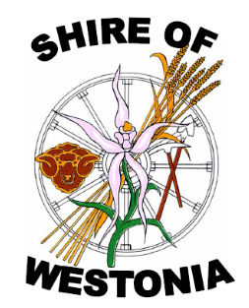 

**Local Emergency Management**

**Arrangements**

The aim of the Shire of Westonia & Yilgarn Local Emergency Management Arrangements (LEMA) is to ensure a written understanding between agencies and stakeholders involved in managing emergencies within the Local Government so that the community is prepared to deal with emergencies should they arise.

|  |  |  |  |
| --- | --- | --- | --- |
| **Document Control** | | | |
| **Document ID** |  | **Version** |  |
| **LEMC Endorsement date** |  | **Last Review** |  |
| **Current Review** |  | **Next Review Date** |  |
| **Prepared by** |  | | |
| **Documents maintained by** |  | | |

**(This page has been intentionally left blank)**

**AUTHORITY**

These arrangements have been produced and issued in compliance with s(41)(1) and (2) of the [*Emergency Management Act 2005*](https://www.legislation.wa.gov.au/legislation/prod/filestore.nsf/FileURL/mrdoc_36944.htm/%24FILE/Emergency%20Management%20Act%202005%20-%20%5B01-a0-01%5D.html?OpenElement) (‘the Act’)*,* endorsed by the Shire of Westonia & Yilgarn Local Emergency Management Committee (LEMC) and Council, the District Emergency Management Committee (DEMC) and State Emergency Management Committee (SEMC).

These arrangements have been developed by personnel within the Shire of Westonia & Yilgarn and the Local Emergency Management Committee. The wider community is constantly consulted.

These arrangements should be read in conjunction with the Emergency Management Act 2005, the State Emergency Management Plans (WESTPLAN), State Hazard Plans (SHP), State Emergency Management Policy Statements, and the Department of Communities’ Local Emergency Management Plan for the Provision of Welfare Support.

Endorsed by:

*________________________________ ­­­ ­­­­­______________________*

Date

Chairperson, LEMC

____________________________________ _________________________

President Shire of Westonia Date

Resolution Number:

____________________________________ _________________________

President Shire of Yilgarn Date

Resolution Number:

Document Review ____________________

Date

**AMENDMENT HISTORY**

|  |  |  |  |
| --- | --- | --- | --- |
| **AMENDMENT** | | **DETAILS OF AMENDMENT** | **AMENDED BY** |
| **NUMBER** | **DATE** | **NAME** |
| 1 | 03/09/2024 | Update Contact and Vulnerable People | Kelly Watts |
|  |  |  |  |
|  |  |  |  |
|  |  |  |  |

Suggestions and Comments from the Community and Stakeholders can help improve these arrangements and subsequent amendments.

To forward feedback, please copy the relevant section, mark the proposed changes and forward to;

The Chairperson

Local Emergency Management Committee Shire *Westonia & Yilgarn*

PO Box 86, Southern Cross, WA 6426

Or email to: [yilgarn@yilgarn.wa.gov.au](mailto:yilgarn@yilgarn.wa.gov.au)

The Chairperson will refer any correspondence to the LEMC for consideration and approval. When updated, amendments promulgated are to be certified in this document.

* [State Emergency Management Policy](https://semc.wa.gov.au/emergency-management/policy)
* [State Emergency Management Plan](https://semc.wa.gov.au/emergency-management/plans)
* [State Emergency Management Procedure](https://semc.wa.gov.au/emergency-management/procedures)
* [State Emergency Management Guidelines](https://semc.wa.gov.au/emergency-management/guidelines)
* [State Emergency Management Glossary](https://semc.wa.gov.au/emergency-management/glossary)

**DISTRIBUTION LIST**

|  |  |  |  |
| --- | --- | --- | --- |
| **Organisation** | **Electronic or Hard Copy** | | **No Copies** |
| Shire of Westonia & Yilgarn |  | |  |
| *Chief Executive Officer’s* | E | | 1 |
| *Shire Offices* | H | | 1 |
| *Shire of Westonia Website* | E | | 1 |
| *Shire of Yilgarn Website* | E | | 1 |
| Emergency Management Committees |  | |  |
| *Chairperson LEMC* | E | | 1 |
| *Committee Members* | E | | 1 |
| *State Emergency Management Committee* | E | | 1 |
| West Australian Police (WAPOL) |  | |  |
| *OIC Police Southern Cross* | E | | 1 |
| Local Emergency Services |  | |  |
| *Chief Bush Fire Control Officer* | E | | 1 |
| *Wheatbelt District Emergency Management Committee* | E | | 1 |
| *Health Service Manager – Southern Cross Hospital* | E | | 1 |
| *VFRS Southern Cross* | E | | 1 |
| *St John Ambulance Sub Centres* | E | | 1 |
| Other External Agencies and neighbours |  | |  |
| *Department of Communities - DESO* | E | | 1 |
| *DBCA – Parks & Wildlife ( Merredin Office)* | E | | 1 |
| *DAFWA Merredin Office* | E | | 1 |
| Western Power – Merredin Office | E | | 1 |
| Water Corporation – Merredin Office | E | | 1 |
|  |  | |  |
|  |  |  | | |

# Table of Contents

Table of Contents 6

SECTION ONE 9

INTRODUCTION 9

1.0 Glossary of Terms 9

1.1 General Acronyms used in these Arrangements: 12

1.2 Disclaimer 13

1.3 Document Availability: 13

1.4 Aim: 14

1.5 Purpose: 14

1.6 Scope: 14

1.7 Area Covered: 14

1.8 Exercising, Reviewing and Reporting: 15

1.9 Local Roles and Responsibilities 15

1.10 LEMC Roles and Responsibilities 17

1.12 Agency Roles and Responsibilities 18

1.13 Related Documents and Arrangements 19

1.14 Community Consultation 21

1.15 Community Awareness 21

SECTION TWO 23

COORDINATION OF EMERGENCIES 23

2.0 Coordination of Emergency Operations. 25

2.1 Incident Management Team (IMT) 25

2.2 Incident Support Group (ISG) 25

2.3 Triggers for AN ISG 25

2.4 Membership of An ISG 26

2.5Frequency of Meetings 26

2.6 Location of Incident Control Centres 26

2.7 Locations of ISG Meetings 26

2.8 Financial Arrangements 27

SECTION THREE 29

RISK 29

3.0 Risk Management 30

3.1 Special Considerations 30

3.2 Critical Infrastructure: 30

3.3 Risk Register: 30

3.4 Emergencies likely to occur / Hazards Register 33

SECTION FOUR 35

EVACUATION 35

Evacuation 36

4.0 Types of Evacuations 36

4.1 The Five Stages of Evacuation 36

4.2 Evacuation (WELFARE) Centres 37

4.3 Evacuation to Other Local Government Areas 37

4.4 Special Needs Groups 38

4.5 Evacuation of Animals 38

4.6 Maps 38

SECTION FIVE 39

WELFARE 39

5.0 Local Emergency Management Plan for the Provision of Welfare Support 40

5.1 Local Welfare Coordinator 40

5.2 Local Welfare Liaison Officer 40

5.3 Register find Reunite 40

5.4 Animal Welfare 40

5.5 Welfare Centre 40

5.6 Shire Emergency Activation Kits 42

SECTION SIX 43

RECOVERY PLAN 43

6.0 Introduction 44

6.1 Roles and Responsibilities 45

6.2 Controlling Agency Hazard Management Agency 47

6.3 State Recovery Coordinator 47

6.4 Recovery Structure State and Local 48

6.5 Commencement of Recovery 49

6.6 Assessment and Operational Recovery Planning: 52

6.7 Resources 52

6.8 Financial Arrangements: 52

6.9 Financial Preparation: 53

6.10 Community Reactions 54

6.11 Actions and Strategies 54

APPENDIX 6A: Sub Committees– Objectives 57

APPENDIX 6B: Aide Memoire Local Recovery Coordinator 58

APPENDIX 6C: Aide Memoire Local Recovery Coordination Group 64

APPENDIX 6D: Operational Recovery Plan Template 69

6.13 Recovery Report 71

SECTION SEVEN 73

COMMUNICATIONS PLAN 73

7.0 Introduction 74

7.1 Communication Policy 74

7.2 Communication Principals 74

7.3 Stakeholder Communication 75

7.4 Communicating in the Prevention Stage: 75

7.5 Communicating in the Preparedness Stage: 75

7.6 Communicating in the Response Stage: 77

7.7 Communicating in the Recovery Stage: 77

APPENDIX 7A Recovery Communications Plan Template 80

SECTION EIGHT 85

CONTACTS AND RESOURCES REGISTER 85

8.0 Local Emergency Management Committee Contacts 90

8.1 Shire Plant and Equipment 93

8.2 Local Resources – Services and Supplies 94

8.3 Emergency Services 95

8.4 Support Organisations 96

8.5 Vulnerable People Contacts Groups 97

**Shire of Westonia & Yilgarn**

 

# SECTION ONE

# INTRODUCTION

1.0 Glossary of Terms

**Australasian Inter-Service Incident Management System (AIIMS):** A nationally adopted structure to formalise a coordinated approach to emergency incident management.

**Combat Agency:** As prescribed under Section 6(2) of the *Emergency Management Act 2005,* a combat agency is to be a public authority or other person who, because of the agency’s functions under any written law or specialised knowledge, expertise and resources, is responsible for performing an emergency management activity prescribed by the regulations concerning that agency.

**Comprehensive Approach:** The development of emergency and disaster arrangements to embrace the aspects of Prevention, Preparedness, Response and Recovery (PPRR). PPRR are aspects of emergency management, not sequential phrases. (Synonyms: disaster cycle, disaster phases and PPRR)

**Command:** The direction of members and resources of an organisation in the performance of the organisation’s role and tasks. Authority to command is established in legislation or by agreement with an organisation. Command relates to organisations and operates vertically within an organisation. (See also *Control* and *Coordination)*

**Control:** The overall direction of emergency management activities in an emergency situation. Control authority is established in legislation or an emergency plan and carries with it the responsibility for tasking and coordinating other organisations to the situation's needs. Control relates to situations and operates horizontally across organisations. (See also *Command* and *Coordination)*

**Controlling Agency:** An agency nominated to control the response activities to a specified type of emergency.

**Coordination:** The bringing together of organisations and elements to ensure an effective response, primarily concerned with the systematic acquisition and application of resources (organisation, workforce and equipment) by the requirements imposed by the threat or impact of an emergency. Coordination is related primarily to resources and operates vertically, within an organisation, as a function of the authority to command and horizontally, across organisations, as a function of the authority to control. (See also *Control* and *Command*)

**District Emergency Management Committee:** A committee established under Section 31(1) of the *Emergency Management Act 2005*

**Emergency:** The occurrence or imminent occurrence of a hazard is of such a nature or magnitude that it requires a significant and coordinated response

**Emergency Coordination Centre:** A facility established to coordinate and organise emergency provision of services.

**Emergency Management:** The management of the adverse effects of an emergency, including

1. prevention: the mitigation or prevention of the probability of the occurrence of an emergency and the potential adverse effects of an emergency.
2. Preparedness: preparation for response to an emergency
3. Response: combating the effects of an emergency, providing emergency assistance for casualties, reducing further damage, and helping speed up the recovery process.
4. Recovery: the support of emergency-affected communities in reconstructing and restoring physical infrastructure, the environment and community, and psychosocial and economic well-being.

**Emergency Management Agency:** A hazard management agency (HMA), a combat or support organisation.

**Hazard:** An event, situation or condition that is capable of causing or resulting in loss of life, prejudice to the safety, or harm to the health of persons or animals; or destruct of; or damage to property or any part of the environment and is defined in the *Emergency Management Act 2005* or prescribed in the *Emergency Management Regulations 2006.*

**Hazard Management Agency (HMA):** A public authority or other person prescribed by the *Emergency Management Regulations 2006* to be a hazard management agency for emergency management, or an aspect of emergency management, of a hazard for a part of that State.

**Incident:** the occurrence or imminent occurrence of a hazard.

**Incident Controller:** The person designated by the Controlling Agency to be responsible for the overall management and control of an incident within an incident area and the tasking of agencies according to the needs of the situation. (Note: Agencies may use different terminology; however, the function remains the same).

**Incident Support Group:** A group of agency/organisation liaison officers convened by the Incident Controller to provide agency-specific expert advice and support concerning operational response to the emergency.

**Local Emergency Coordinator:** The person appointed by the State Emergency Coordinator to provide advice and support to their local emergency management committee in the development and maintenance of emergency management arrangements, assist hazard management agencies in the provision of a coordinated response during an emergency in the district and carry out other emergency management functions under the direction of the State Emergency Coordinator.

**Local Emergency Management Committee:** A committee established under Section 38 of the

*Emergency Management Act 2005.*

**Operational Area:** The area defined by the Operational Area Manager for which they are responsible for the strategic management of an emergency. This area may include one or more Incident Areas.

**Preparedness:** Preparation for response to an emergency.

**Prevention:** The mitigation or prevention of the probability of the occurrence of an emergency and the potential adverse effects of an emergency.

**Public Authority:** An agency as defined in the *Public Sector Management Act 1994;*

* + A body, corporate or unincorporated, that is established or continued for a public purpose by the State, regardless of the way it is established;
  + A local government or regional local government;
  + The Police Force of Western Australia;
  + A member or officer of a body referred to in one of the above or
  + A person or body prescribed (or of a class prescribed) by the regulations as a public authority for this definition

**Recovery:** Supporting emergency-affected communities in reconstructing and restoring physical infrastructure, the environment and community, and psychological and economic well-being.

**Response:** The combatting of the effects of an emergency, provision of emergency assistance for casualties, reduction of further damage, and help to speed recovery.

**Risk:** A concept used to describe the likelihood of harmful consequences arising from the interaction of hazards, communities and the environment.

* + The chance of something happening that will have an impact on objectives. It is measured in terms of consequences and likelihood;
  + A measure of harm, taking into account the consequences of an event and its likelihood. For example, it may be expressed as the likelihood of death to an exposed individual over a given period, and
  + Expected losses (of lives, persons injured, property damaged, and economic activity disrupted) due to a particular hazard for a given area and reference period. Based on mathematical calculations, risk is the product of hazard and vulnerability.

**Standard Operating Procedure:** A set of directions detailing what actions could be taken, as well as how, when, by whom and why, for specific events or tasks.

**State Emergency Management Committee:** A committee established under Section 13 of the

*Emergency Management Act 2005.*

**Vulnerability:**

The characteristics and circumstances of a community, system or asset make it susceptible to the damaging effects of a hazard. Many aspects of vulnerability arise from various physical, social, economic and environmental factors that vary within a community and over time.

**Welfare:** The provision of immediate and continuing care of emergency affected persons who may be threatened, distressed, disadvantaged, homeless or evacuated; and the maintenance of health, well-being and prosperity of such persons with all available community resources until their rehabilitation is achieved.

1.1 General Acronyms used in these Arrangements:

|  |  |
| --- | --- |
| **BFS** | Bush Fire Service |
| **BFB** | Bush Fire Brigade |
| **CA** | Controlling Agency |
| **CEO** | Chief Executive Officer |
| **DC** | Department of Communities |
| **DEMC** | District Emergency Management Committee |
| **ECC** | Emergency Coordination Centre |
| **DFES** | Department of Fire and Emergency Services |
| **FRS** | (Volunteer) Fire and Rescue Service |
| **HMA** | Hazard Management Agency |
| **ISG** | Incident Support Group |
| **LEC** | Local Emergency Coordinator |
| **LEMA** | Local Emergency Management Arrangements |
| **LEMC** | Local Emergency Management Committee |
| **LG** | Local Government |
| **LRC** | Local Recovery Coordination |
| **LRCC** | Local Recovery Coordinating Committee |
| **MOU** | Memorandum of Understanding |
| **NGO** | Non-governmental organisation |
| **PaW** | Parks and Wildlife Service (Department of Biodiversity, Conservation and Attractions) |
| **SEC** | State Emergency Coordinator |
| **SEMC** | State Emergency Management Committee |
| **SES** | State Emergency Service |
| **SEWS** | State Emergency Warning Signal |
| **SHC** | State Health Coordinator |
| **SJA** | St John Ambulance |
| **WA HEALTH** | Department of Health |
| **WAPOL** | WA Police Force |

1.2 Disclaimer

The Shire of *Westonia & Yilgarn* makes no representations about the suitability of the information contained in this document or any material related to this document for any purpose. The document is provided with no warranty to the extent permitted by law. At this moment, the Shire of Westonia & Yilgarn disclaims all warranties and conditions about this information, including all implied warranties and conditions of merchantability, fitness for a particular purpose, title and non-infringement. In no event shall the Shire of Westonia & Yilgarn be liable for any special, indirect or consequential damages resulting from the loss of use, data or profits, whether in an action of contract, negligence or other tortuous action, arising out of or in connection with the use of information available in this document. The document or material related to this document could include technical inaccuracies or typographical errors.

1.3 Document Availability:

A copy of this document is available on the Shire of *Westonia & Yilgarn* website: [www.yilgarn.wa.gov.au](http://www.yilgarn.wa.gov.au) [www.westonia.wa.gov.au](http://www.westonia.wa.gov.au)

A print copy of this document (public version) will be made available to the public at the Shire of *Westonia & Yilgarn* administration building at:

* *23 Antares Street, Southern Cross: &*
* *41 Wolfram Street, Westonia.*

An electronic copy of this document (confidential version) is available to all Local Emergency Management Committee members.

1.4 Aim:

To detail emergency management arrangements and ensure understanding between agencies and stakeholders in managing emergencies within the Shire.

1.5 Purpose:

To set out;

* + The Shire of *Westonia & Yilgarn* policies for emergency management
  + The roles and responsibilities of public authorities and other persons involved in emergency management
  + Provisions about the coordination of the emergency operations performed by the public authorities and other persons
  + Description of emergencies likely to occur within the Shire of *Westonia & Yilgarn*
  + Strategies and priorities for emergency management in the district
  + Other matters about emergency management in the Shire of Westonia & Yilgarn that the Shire of *Westonia & Yilgarn* considers appropriate

1.6 Scope:

These arrangements ensure the community is prepared to deal with the identified emergencies should they arise. This document does not detail the procedures for HMAs in dealing with an emergency. These should be detailed in the HMAs' individual plans.

* + This document applies to the local government district of the Shire of *Westonia & Yilgarn*
  + This document covers areas where the Shire of *Westonia & Yilgarn* supports HMAs in the event of an incident.
  + This document details the Shire of *Westonia & Yilgarn's capacity to provide resources in support of an emergency while maintaining business continuity and the Shire of Westonia & Yilgarn's responsibilities concerning* recovery management.

The arrangements are to serve as a guide for use at the local level. Incidents may arise that require action or assistance from the district, state, or federal levels.

1.7 Area Covered:

The Shire of Westonia is located approximately 316 kilometres east of Perth. Its population is approximately 277 people and covers an area of 3,268 square kilometres. The shire includes the towns of Walgoolan, Carrabin, Warralakin, and the main centre of Westonia.

The Shire of Yilgarn is located approximately 370 kilometres East of Perth. It encompasses an area of 30,720 square km, has a population of approximately 1,600, and includes the localities of Southern Cross, Bodallin, Bullfinch, Ghooli, Koolyanobbing, Marvel Loch, Moorine Rock, and Yellowdine.

1.8 Exercising, Reviewing and Reporting:

Exercising:

Exercising is the simulation of emergency management events through discussion or actual deployment of personnel in order to train personnel, review/test the planning process or other procedures, identify needs and/or weaknesses, demonstrate capabilities, and enable people to practice working together. The different types of exercises include Discussion, Field, Tabletop, and Tactical Exercise without Troops.

Testing and Exercising are important for a number of reasons, including ensuring that the Emergency Management Arrangements are workable, current, and effective and that individuals and organisations remain aware of what is required of them during an emergency response situation.

The Shire of *Westonia & Yilgarn* Local Emergency Management Committee exercises its arrangements once a year as per State Emergency Management Policy 4.8 and State Emergency Management Plan 4.7.

Hazard Management Agencies are responsible for exercising their response to an incident, but this could be incorporated into a LEMC exercise.

In alignment with section 4.7 of the State Emergency Management Plan, an exercise report should be developed as soon as practical after the exercise's completion and sent to the Wheatbelt DEMC executive officer for tabling at the next meeting.

Reviewing:

An entire review of the emergency management arrangements should be undertaken

* After an event or incident requiring the activation of an Incident Support Group or after an incident requiring significant recovery co-ordination.
* Every five years and;
* Whenever the local government considers it appropriate.

The Contacts and Resources list should be reviewed and updated as needed but at a minimum quarterly.

Reporting:

The annual LEMC Report should be submitted to the District Emergency Management Committee (DEMC) in conjunction with the preparedness Capability Survey as directed each year by the SEMC.

1.9 Local Roles and Responsibilities

|  |  |
| --- | --- |
| Local Role | Description of Responsibilities |
| Local Government | The responsibilities of the Shire of *Westonia & Yilgarn* are defined in s.36 of the Emergency Management Act 2005  It is a function of a local government –  subject to this Act, to ensure that adequate local emergency management arrangements are prepared and maintained for its district and  to manage recovery following an emergency affecting the community in its district and to perform other functions given to the local government under this Act |
| Local Emergency Coordinator | The responsibilities of the LEC are defined in s37(4) of the  *Emergency Management Act 2005*   1. The Local Emergency Coordinator for a local government district has the following functions – 2. to provide advice and support to the local emergency management committee for the district in the development and maintenance of emergency management arrangements for the district; 3. to assist hazard management agencies in the provision of a coordinated response during an emergency in the district; 4. to carry out other emergency management activities by the directions of the State Emergency Coordinator |
| Local Recovery Coordinator | To ensure the development and maintenance of adequate recovery management arrangements for the local government. In conjunction with the local recovery committee, implement a post-incident recovery action plan and manage the recovery phase of the incident. |

|  |  |
| --- | --- |
| Local Government Welfare Liaison Officer | During an evacuation, assist Dept. Communities by providing advice, information and resources  (a) open and establish a welfare centre at the nominated facility until the arrival of DC;  (b) establish the registration process of evacuees until the arrival of DC;  (c) provide advice, information and resources in support of the facility; and  (d) assist with maintenance requirements for the facility. |
| Local Government Liaison Officer (to ISG/IMT) | During a major emergency, the liaison officer attended ISG meetings to represent the local government, provide local government knowledge input, and provide details in the LEMA. |
| Local Government – Incident Management | * Ensure planning and preparation for emergencies is undertaken * Implement procedures that assist the community and emergency services in dealing with incidents * Ensure all personnel with emergency planning and preparation, response and recovery responsibilities are adequately trained in their role * Keep appropriate records of incidents to ensure continual improvement of the Shire's emergency response capability. * Liaise with the incident controller (provide liaison officer) * Participate in the IMT/ISG and provide local support * Where an identified evacuation centre is a building owned and operated by the local government, provide a liaison officer to support the Department of Communities. |

1.10 LEMC Roles and Responsibilities

The Shire of Westonia & Yilgarn has established a Local Emergency Management Committee (LEMC) as per section 38(1) of the *Emergency Management Act 2005* to oversee, plan and test the local emergency management arrangements.

The LEMC is not an operational committee but rather an organisation established by the local government to assist in developing local emergency management arrangements for its district.

The LEMC includes representatives from agencies, organisations, and community groups relevant to the identified risks and emergency management arrangements for the community. The LEMC membership must include at least one local government representative and the Local Emergency Coordinator. The local government shall determine the term of appointment of LEMC members in consultation with the members' parent organisation.

The Shire of *Westonia & Yilgarn* LEMC meets quarterly, *(for example) generally on the third Tuesday of every February, April, August, and October.*

|  |  |
| --- | --- |
| **LEMC Role** | **Description of Responsibilities** |
| LEMC Chair | Provide leadership and support to the LEMC to ensure effective meetings and high levels of emergency management planning and preparedness for the local government district are undertaken. |
| LEMC Executive Officer | Provide executive support to the LEMC by Facilitating the provision of secretariat support, including:   * Meeting agenda; * Minutes and action lists; * Correspondence; * Maintain committee membership contact register   Coordinate the development and submission of committee documents by legislative and policy requirements, including:   * Annual Report * Annual Business Plan * Maintain Local Emergency Management Arrangements;   Facilitate the provision of relevant emergency management advice to the Chair and committee as required and   * Participate as a member of sub-committees and working groups as required |

1.11 LEMC Membership

The local government established the LEMC to develop, overview, plan, and test the local emergency management arrangements convened every three months. The committee includes representatives of agencies, organisations and community groups with expertise relevant to the identified community hazards and risks and emergency management arrangements. Members of the Shire’s LEMC include representatives from DFES, Shire of *Westonia & Yilgarn* councillors and staff, WA Police, WA Department of Health, and the Department of Communities, as well as business and community representatives. The LEMC also facilitates training and exercises for emergency management.

For current LEMC membership names and contacts, please see the LOCAL EMERGENCY MANAGEMENT COMMITTEE CONTACTS Section—this is only available to LEMC members and Emergency Management professionals.

1.12 Agency Roles and Responsibilities

In the event of an emergency, the local government will need to liaise with a range of state agencies involved in the emergency's operational aspects. The following table summarises the key roles:

|  |  |
| --- | --- |
| **Agency Roles** | **Description of Responsibilities:** |
| Controlling Agency | A Controlling Agency is nominated to control the response activities to a specified type of emergency.  The function of a Controlling Agency is to;   * Undertake all responsibilities as prescribed in Agency specific legislation for Prevention and Preparedness * Control all aspects of the response to an incident * During Recovery, the Controlling Agency will ensure an effective transition to recovery |
| Hazard Management Agency | An HMA is to be a public authority or another person who or which, because of that agency’s functions under any written law or specialised knowledge, expertise and resources, is responsible for emergency management, or the prescribed emergency management aspect, in the area prescribed of the hazard for which it is prescribed.”  A HMA’s function is to:   * Undertake responsibilities where prescribed for these aspects * Appointment of Hazard Management Officers * Declare/Revoke Emergency Situation * Coordinate the development of the West plan for that hazard * Ensure effective transition to recovery by Local Government |
| Combat Agency | A combat agency, as prescribed under Subsection (1) of the Emergency Management Act 2005, is to be a public authority or other person who or which, because of that agency’s functions under any written law or specialised knowledge, expertise and resources, is responsible for performing an emergency management activity prescribed by the regulations about that agency. |
| Support Organisation | A Public authority or other person who or which, because of the agency’s functions under any written law or specialised knowledge, expertise and resources, is responsible for providing support functions in relation to that agency. |

1.13 Related Documents and Arrangements

**Local Emergency Management Policies:**

As per section 41(2)(a) of the *Emergency Management Act 2005,* the local emergency management arrangements need to specify “the local government policies for emergency management”. The Shire of *Westonia & Yilgarn* has the following emergency management policies in place:

|  |  |
| --- | --- |
| ***Policy Name*** | ***Policy Objective*** |
| *Shire of Yilgarn*  *1.6 Media Policy* | *To provide a framework for Councillors, staff, delegates and advisers to:*  *• Ensure all communication with the media is consistent, balanced, well- informed, timely, professional and appropriate.*  *• Clearly indicate Council’s authorised spokespersons.*  *• Improve communication with customers and enhance Council’s public image.*  *• Limit the possibility of miscommunication and maximise the effectiveness of staff by ensuring comments to the media relating to the Council are made only through authorised people.* |
| *Shire of Yilgarn*  *2.1 Use Of Council Equipment* | *That Council plant and equipment used for firefighting purposes be made available for firefighting and protective burning as required, subject to consultation with the Council’s senior management staff and the Chief Bush Fire Control Officer or a person acting in this position.* |
| *Shire of Yilgarn*  *2.2 Harvest and Vehicle Movement Bans* | *That the Chief Bushfire Control Officer and Deputy Chief Bushfire Control Officer be authorised to impose a Total Movement Ban, including the movement of vehicles in paddocks* |
| *Shire of Yilgarn*  *2.4 Bush Fire Advisory Committee Policy* | *To set guidelines for the operation of the Shire of Yilgarn Bush Fire Advisory Committee.* |

**Existing Plans and Arrangements:**

|  |  |  |  |
| --- | --- | --- | --- |
| **Document** | **Owner** | **Location** | **Date of Plan** |
| *Southern Cross Hospital Continuity Plan* | *Dept Health* | *Southern Cross Hospital* |  |
| *Crash (air, plane, road)* | *WAPOL* | *Local Police Station* |  |
| *Land Search* | *WAPOL* | *Local Police Station* |  |
| *Terrorism* | *WAPOL* | *Local Police Station* |  |
| *Local Welfare Plan – Northam district* | *Dept. Communities* | *Shire of Westonia & Yilgarn* |  |

**Local Agreements, Understanding and Commitments**

The Shire of *Westonia & Yilgarn* is continuing to work towards providing Mutual Aid during Emergencies and Post-Incident Recovery.

|  |  |  |  |
| --- | --- | --- | --- |
| *Business* | *Type* | *Summary of Agreement* | *Special Considerations* |
| WEROC Bruce Rock,  Merredin,  Kellerberrin,  Westonia &  Yilgarn Shires | Member Councils | Memorandum of Understanding  to outline the assistance provided  by member groups during an  emergency and during the  recovery process. | N/A |

1.14 Community Consultation

The Shire of Westonia & Yilgarn developed these arrangements in consultation with the Shire of *Westonia & Yilgarn* Local Emergency Management Committee.

* *Community representatives are encouraged to become members of the LEMC*
* *The LEMC seeks community leaders to assist with consultations.*
* *Through utilisation o of the Shire Facebook and website pages*

1.15 Community Awareness

The Shire of *Westonia & Yilgarn* LEMC makes every effort to increase community awareness of emergency management.

*(examples)*

* *EM news, including raising awareness of risks and preparedness measures provided in local newspapers/newsletters and social media platforms. (i.e. storm season preparedness, bush fire awareness)*
* *invites to major exercises*
* *emergency management days*
* *workshops and information days*
* *Encourage LEMC members to share learnings with family, friends and colleagues and to disseminate information through their agencies.*

**(This page has been intentionally left blank)**

**Shire of Westonia & Yilgarn**

 

**AUSTRALASIAN INTER-SERVICE INCIDENT MANAGEMENT SYSTEM (AIIMS)**

# SECTION TWO

# COORDINATION OF EMERGENCIES

In a multi-agency system, incident management comprises command, control and coordination.

Control maintains the overall direction of emergency response. To effectively control an emergency, incidents should be managed by a single person. (The Incident Controller)

Command is the direction of resources within the agencies committed to the emergency.

Coordination brings together agencies and resources to ensure adequate response to and recovery from emergencies.

Emergency management agencies need a common framework of roles, responsibilities, and processes to work together effectively. In Australia, AIIMS is the nationally recognised system of incident management. It is founded on five key principles and has eight key functions identified within the structure.

The five fundamental principles of AIIMS:

|  |  |
| --- | --- |
| **Unity of Command** | Each individual should report to only one Supervisor. There is only one Incident Controller, one set of objectives, and one plan for managing the incident. |
| **Span of Control** | Refers to the number of groups or individuals one person can successfully supervise. Up to five reporting groups/individuals are considered desirable, occasionally more. |
| **Functional Management** | Functions are performed and managed by the Incident Controller or his/her delegates. There are eight key areas of functional management; the Incident Controller and heads of the functional sections are collectively the Incident Management Team (IMT). |
| **Management by Objectives** | In consultation with the IMT, the Incident Controller determines the desired outcomes of the incident. |
| **Flexibility** | AIIMS can be applied to any incident or emergency, so a flexible approach is essential. |

The eight possible functions of AIIMS:

|  |  |
| --- | --- |
| **Control** | Management of all activities required to resolve the incident. |
| **Planning** | Development of objectives, strategies and plans for the resolution of the incident. |
| **Intelligence** | We collect and analyse information or data distributed as intelligence to support decision-making and planning. |
| **Public Information** | Provide warnings, information, and advice to the public and liaise with the media and community. |
| **Operations** | Tasking and application of resources. |
| **Investigation** | Investigating to determine the cause of and the factors contributing to the impact of the incident. |
| **Logistics** | Acquisition and provision of human and physical resources, facilities, services and materials. |
| **Finance** | Managing accounts for purchases of supplies, hire of equipment, etc. Insurance and compensation for personnel, property and vehicles. Collection of cost data, provision of cost-effect analyses, and provision of cost estimates for the incident. |

2.0 Coordination of Emergency Operations.

It is recognised that the HMAs and combat agencies may require local government resources and assistance in emergency management. The Shire of Westonia & Yilgarn is committed to providing assistance if the required resources are available through the Incident Support Group when and if it is formed.

**The Local government liaison officer will attend the IMT and ISG as required to provide the link between operations and the local government.**

2.1 Incident Management Team (IMT)

An IMT comprises incident management personnel, including the Incident Controller and the personnel they appoint to be responsible for operations, planning, and logistics. An Incident is controlled by a Controlling Agency, which will nominate an Incident Controller who has delegated authority to manage the incident's control. The Incident Controller leads the team and is responsible for the overall control of the response to the incident. As an incident scales up and down in size, so does the size of the IMT.

2.2 Incident Support Group (ISG)

An ISG's role is to support the Incident Management Team (IMT). The ISG is a group of people represented by the different agencies that may have been involved in the incident and who provide support to the Controlling Agency.

2.3 Triggers for AN ISG

An ISG is triggered when the incident is a “Level 2” or higher, and multiple agencies must be coordinated.

Classification of Incidents:

|  |  |  |
| --- | --- | --- |
| **Level** | **Description** | **Local Response Required** |
| **Level One** | Usually resolved through local or initial response resources | Provide support to resolve the incident at the local level |
| **Level Two** | Requiring resource deployment beyond initial response, functional sections established due to complexity. | Provide support to resolve the incident at a local level. Provide a Local Government Liaison Officer to the ISG. Make facilities available to the HMA as evacuation centres. |
| **Level Three** | Complexity may require establishing divisions for effective management, which usually involves delegating all functions. | Provide support to resolve the incident at a local level. Provide Local Government Liaison Officers to the ISG and /or OASG. Make facilities available to the HMA as evacuation centres. |

2.4 Membership of An ISG

The recovery coordinator should be a member of the ISG from the outset to ensure consistency of information flow, situational awareness, and handover to recovery. However, the representation of this group may change regularly depending upon the nature of the incident, the agencies involved, and the consequences caused by the incident.

Agencies supplying staff/liaison officers for the ISG must ensure that the representative(s) have the authority to commit resources and direct tasks.

2.5Frequency of Meetings

The frequency of meetings will be determined by the Incident Controller and will depend on the nature and complexity of the incident. At a minimum, there should be at least one meeting per incident.

2.6 Location of Incident Control Centres

|  |  |
| --- | --- |
| *Location* | *Address* |
| *Shire of Yilgarn Administration Centre* | *23 Antares Street, Southern Cross* |
| *Shire of Westonia Administration Centre* | *41 Wolfram Street, Westonia* |

2.7 Locations of ISG Meetings

The location of ISG meetings will be determined by the Incident Controller. They should not be held in the midst of the incident or at the same location as meetings of the incident management team.

The following locations can be used for ISG meetings:

|  |  |
| --- | --- |
| *Location* | *Address* |
| Shire of Yilgarn Works Depot Office | 24-28 Arcturus Street, Southern Cross |
| Westonia Recreation Complex | Cement Street, Westonia |

For a list of contacts to open these locations for ISG meetings, please refer to INCIDENT SUPPORT GROUPS MEETING LOCATIONS AND CONTACTS in the Contacts and Resources Section.

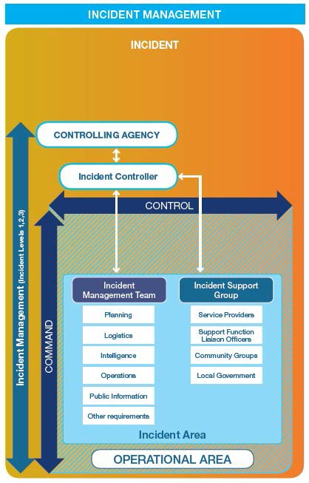

Figure 1: A diagram illustrating Incident Management

2.8 Financial Arrangements

The Shire of *Westonia & Yilgarn* is committed to expending such necessary funds within its current budgetary constraints as required to ensure the safety of its residents and visitors. The Chief Executive Officer should be approached immediately if an emergency event requiring resourcing by the Shire of *Westonia & Yilgarn* occurs to ensure the desired level of support is achieved.

**(This page has been intentionally left blank)**

**Shire of Westonia & Yilgarn**

 

# SECTION THREE

# RISK

3.0 Risk Management

Risk Management is a vital part of the emergency management process. We must understand the hazards and risks likely to impact the Shire of Westonia & Yilgarn.

The Shire of Westonia & Yilgarn LEMC has considered several special considerations when considering risks affecting our community. They are listed below.

3.1 Special Considerations

*Consider the following:*

* *Seasonal events*
* *Tourist influx periods and locations*
* *Seasonal hazards*
* *Major community events.*
* *(Vulnerable groups will be specifically mentioned in the contacts and resources register.)*

3.2 Critical Infrastructure:

The following assets/infrastructure located within the Shire of *Westonia & Yilgarn* and have been classified as critical infrastructure: *(consider essential services that, if affected, will have impacts on your community)*

|  |  |  |
| --- | --- | --- |
| Infrastructure | *Owner* | *Address* |
| TV/Radio/ Internet Tower | Shire of Yilgarn | Wimmera Hill Southern Cross |
| Radio Repeater Station | Shire of Yilgarn | Burbidge Street, Marvel Loch |
| Sewage Pump Stations  Southern Cross | Shire of Yilgarn | Arcturus St (North end),  Archenar St (Near Oval),  Caravan Park |
| Sewage Pump Stations Marvel Loch | Shire of Yilgarn | Lenneberg St (upon entry to the townsite),  Overington St, end of bitumen |
| Great Eastern Highway | Main Roads | Kalgoorlie Office, Boulder Depot |
| Goldfields Water pipeline? Pumping stations? | Water Corporation | Kalgoorlie Office |
| Mines? | Barto Gold  Mineral Resources  Edna May | Marvel Loch  Koolyanobbing, Parkers Range, Windarling`  Westonia |
| Schools | Westonia Primary School |  |
| Schools | Moorine Rock Primary  St Joseph’s School  Southern Cross District High | Moorine South Road  Altair Street  Antares Street |
| Hospital | Southern Cross Hospital | Great Eastern Highway, Southern Cross |
| Airfield Southern Cross | Southern Cross Airfield | Great Eastern Highway, Southern Cross |
| Airstrip Westonia | Westonia Airstrip | Carrabin-Westonia Road |

3.3 Risk Register:

The Shire of *Westonia & Yilgarn* LEMC has undertaken extensive risk assessment work to understand our local capability and capacity better.

During this work, three hazards were identified as the most likely to occur in the region, and credible, worst-case scenarios were developed for all of them. The LEMC then workshopped the scenarios against multiple impact statements and developed a risk register that assigned each impact statement scenario a risk level, rating from Extreme to Very Low. The project's findings are summarised below.

**SHIRE OF YILGARN**

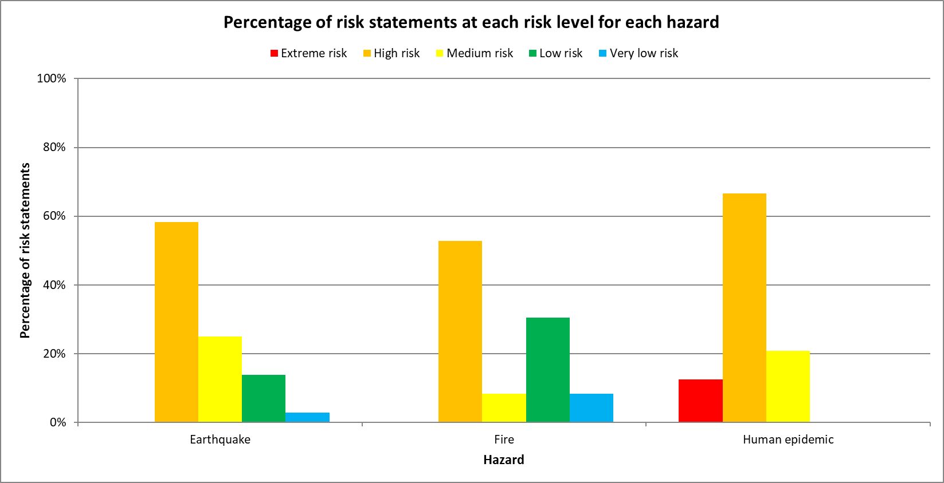

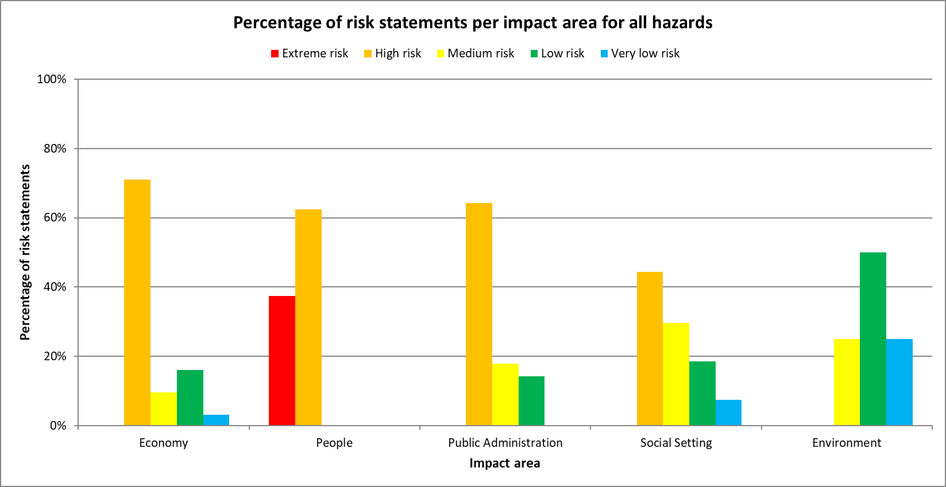

The risk register is available at the Shire of *Yilgarn* for further information.

**SHIRE OF WESTONIA**

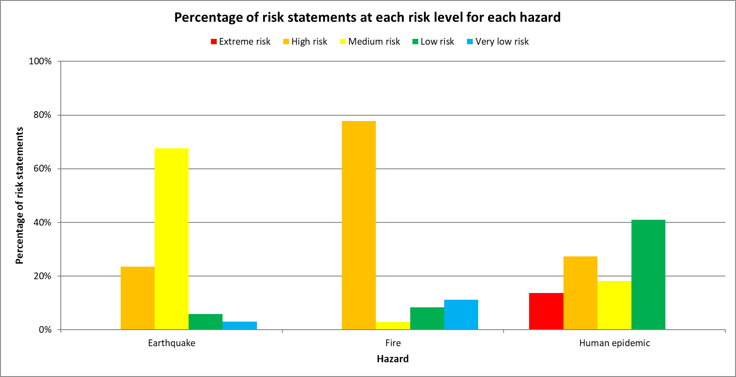

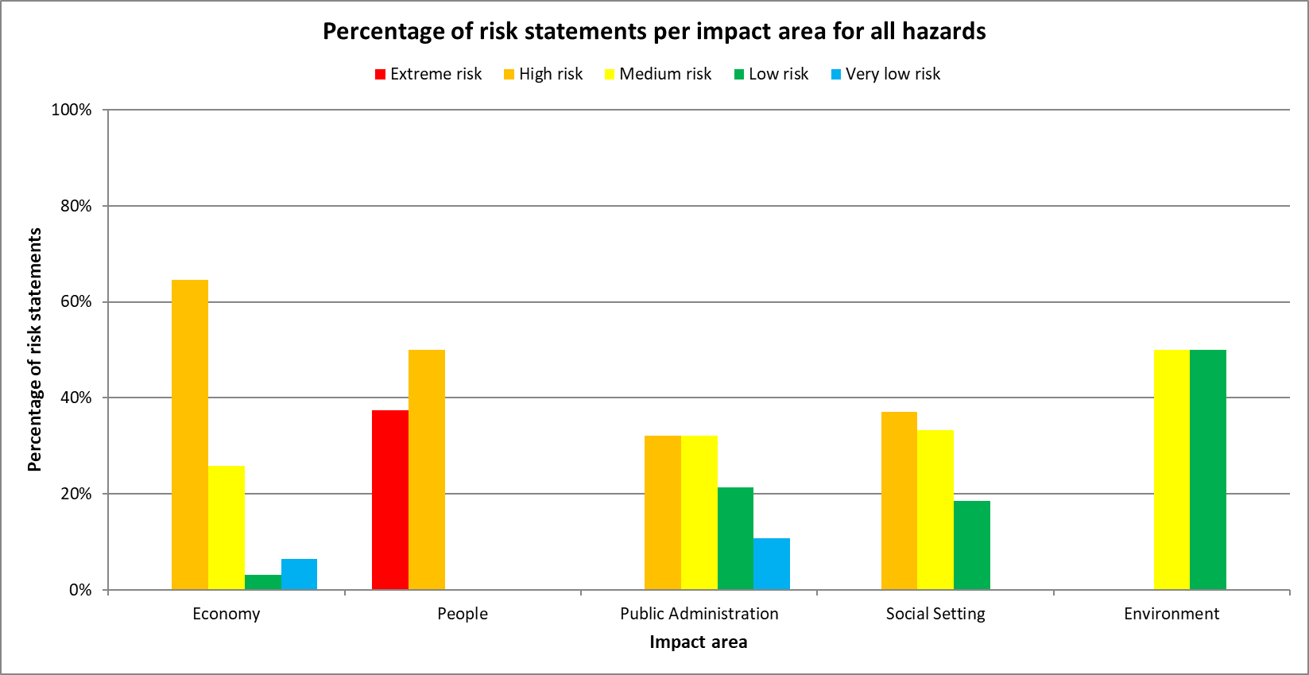

The risk register is available at the Shire of *Westonia* for further detailed information.

3.4 Emergencies likely to occur / Hazards Register

The following hazards were identified as the most likely to occur in the Shire. Below is a register of the identified hazards.

|  |  |  |  |  |  |  |
| --- | --- | --- | --- | --- | --- | --- |
| **Hazard** | **HMA** | **Controlling agency** | **Local Combat Role** | **Local Support Role** | **State Hazard Plan (Westplan)** | **Local Plan** |
| *Fire*  *(Local Govt Land)* | *DFES* | *LG* | *VBFB – Southern Cross* | *LGA staff* | *Fire 2019* | *Response plan?* |
| *Fire (Structure in Gazetted town boundary)* | *DFES* | *DFES* | *VFRS – Southern Cross* | *LGA Staff,*  *Police, SJA* | *Fire 2019* | *SOPs* |
| *Electricity Supply Disruption* | *Public*  *Utilities*  *Office* | *Public Utilities Office* | *Western Power* | *Western Power* |  |  |
| *Pandemic* | *Dept of Health* | *Dept of Health* | *Health Services* | *Southern Cross Hospital* | *Human Epidemic 2016* | *SOPs* |
| *Road Crash* | *WA Police Force* | *WA Police Force* | *VFRS – Southern Cross* | *Police, SJA, Hospital, LG Staff* | *Crash Emergency 2018* | *SOPs* |

**Shire of Yilgarn**

|  |  |  |  |  |  |  |
| --- | --- | --- | --- | --- | --- | --- |
| **Hazard** | **HMA** | **Controlling agency** | **Local Combat Role** | **Local Support Role** | **State Hazard Plan (Westplan)** | **Local Plan** |
| *Fire*  *(Local Govt Land)* | *DFES* | *LG* | *VBFB - Merredin* | *LGA staff* | *Fire 2019* | *Response plan?* |
| *Fire (Structure in Gazetted town boundary)* | *DFES* | *DFES* | *VFRS - Merredin* | *LGA Staff,*  *Police, SJA* | *Fire 2019* | *SOPs* |
| *Electricity Supply Disruption* | *Public*  *Utilities*  *Office* | *Public Utilities Office* | *Western Power* | *Western Power* |  |  |
| *Pandemic* | *Dept of Health* | *Dept of Health* | *Health Services* | *Merredin Hospital* | *Human Epidemic 2016* | *SOPs* |
| *Road Crash* | *WA Police Force* | *WA Police Force* | *VFRS* | *Police, SJA, Hospital, LG Staff* | *Crash Emergency 2018* | *SOPs* |

**Shire of Westonia**

**Shire of Westonia & Yilgarn**

 

# SECTION FOUR

# EVACUATION

Evacuation

During an emergency, circumstances may arise where the need to totally or partially evacuate the population of an area due to risk may arise.

The Shire of Westonia & Yilgarn and its LEMC are dedicated to ensuring pre-emergency evacuation planning so that, if an emergency were to occur, the risks associated with evacuation could be mitigated.

The Controlling Agency has overall responsibility for a community evacuation. The decision to evacuate rests with the Incident Controller, who is appointed by the Hazard Management Agency or Controlling Agency.

When considering an evacuation, the Hazard Management Agency or Controlling Agency must consult with the Shire of Westonia & Yilgarn and the Department of Communities.

4.0 Types of Evacuations

***Self-evacuation*** is the spontaneous, self-initiated movement of individuals, families, or community groups when threatened by an emergency. The Controlling Agency should provide sufficient, timely, and relevant information to the community to assist in their making an informed decision to self-evacuate.

A **c*ontrolled evacuation*** is the managed movement of people from a threatened area to a place of safety. The decision to undertake a controlled evacuation will be made by the Controlling Agency or an Authorised Officer, who will determine whether the evacuation will be recommended (voluntary) or directed (compulsory).

A ***recommended evacuation*** is a type of controlled evacuation in which the Hazard Management Agency or Controlling Agency advises community members to evacuate when the Incident Controller believes that is the best option. It is made when there is a possible threat to lives or property, but it is not believed to be imminent or significant.

A ***directed evacuation*** is a type of controlled evacuation in which the Hazard Management Agency or Controlling Agency issues a direction for people and animals to evacuate, with which they are obliged to comply. This is most likely to occur when injury or loss of life is imminent.

4.1 The Five Stages of Evacuation

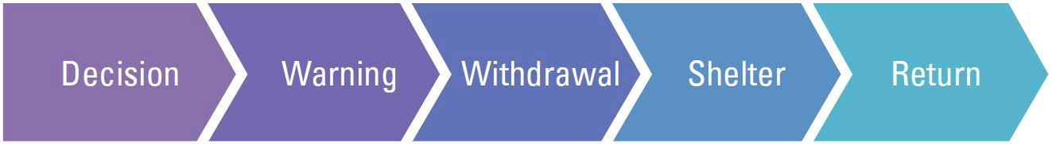

Things to Consider: Legislative powers, risk management, resource requirements. Reasons to/not to evacuate must be recorded.

**Stage Two: Warning** – Telling people of the need to go

Part of the LEMC’s planning process is identifying available communication methods for public information.

**Stage Three: Withdrawal** – Getting people out

Self-evacuation, recommended evacuation or directed evacuation?

The Controlling Agency should, as far as practicable, ensure the security of the evacuated area and of the remaining persons and property. Assistance with this may be sought from WAPOL, local government, and security and/or traffic management contractors.

**Stage Four: Shelter** – Where people can go and provide support

Where a Controlling Agency establishes one or more evacuation centres, it must take reasonable steps to ensure that evacuees are appropriately received and supported by welfare agencies and/or the local government. The Department of Communities will coordinate providing welfare support for evacuated persons.

**Stage Five: Return** – Allowing people back and supporting their return

In most circumstances, the return of the affected community is the responsibility of the Controlling Agency, which determines the need for an evacuation in the first place. In instances where a hazard's impacts have had lasting effects, the incident may have been handed over to a Recovery Coordinator and/or Recovery Committee at the State or Local level.

A relevant person will need to ensure that an appropriate assessment has been carried out to confirm that the area is safe and possible to return to. The return may be executed in stages as the operational plan should consider issues such as community safety, restoration of essential services and provision of welfare support services.

4.2 Evacuation (WELFARE) Centres

Please refer to section Five, Welfare, for a complete list of evacuation centres.

4.3 Evacuation to other Local Government Areas

The Shire of Westonia & Yilgarn and its LEMC have planned for an eventuality in which evacuation to all local welfare centres is impossible. Partnering agreements with surrounding Shires have yet to be developed.

**The Shire of Merredin is 50 km and 109 km, respectively, travelling east along the** Great Eastern Highway.

Alternative Route: Gabbin/ Trayning Road (joins Koorda Bullfinch Road)

|  |  |  |  |
| --- | --- | --- | --- |
| **FACILITY** | **CAPACITY** | **ADDRESS** | **CONTACT** |
| Merredin  Regional  Community  & Leisure  Centre | 500 | Bates Street,  Merredin | Centre Manager 9041 3033 |
|  |  |  |  |

4.4 Special Needs Groups

A list of contacts to coordinate the contact of Vulnerable People within the Shire is available in the Contacts and Resources section under VULNERABLE PEOPLE CONTACT GROUPS. The corresponding group/business is responsible for maintaining and updating the individual lists for the vulnerable people they are responsible for.

4.5 Evacuation of Animals

Assistance animals are welcomed at all welfare centres. For a list of pet evacuation locations, please refer to ANIMAL WELFARE within the Contacts and Resources section.

4.6 Maps

*The Shire Administration Office has detailed maps showing key routes, the location of evacuation centres, and other required information.*

**Shire of Westonia & Yilgarn**

 

# SECTION FIVE

# WELFARE

## 5.0 Local Emergency Management Plan for the Provision of Welfare Support

The Department of Communities has the role of managing welfare. The Shire of Westonia & Yilgarn falls under the Merredin district of the Department of Communities. They have developed a Local Emergency Management Plan for the Provision of Welfare Support, which aims to prescribe the arrangements for providing welfare support services during emergencies. The plan is available from the Shire of Westonia & Yilgarn and the Department of Communities. The plan contains private contact details of key personnel and is not for public distribution.

## 5.1 Local Welfare Coordinator

The Local Welfare Coordinator for the Shire of Westonia & Yilgarn is the Northam Department of Communities Office Team Leader. Their contact details can be found in the Contacts and Resources section.

## 5.2 Local Welfare Liaison Officer

The local government appoints the Local Welfare Liaison Officer to coordinate welfare response during emergencies and to liaise with the Local Welfare Coordinator. This role will assist the Local Welfare Coordinator manage emergency evacuation centres such as building openings, closings, security, and maintenance.

The Shire of Westonia & Yilgarn appointed Local Welfare Liaison officer is the Shire of Yilgarn Regulatory Services Officer.

## 5.3 Register to find Reunite

When a large-scale emergency occurs and people are evacuated or become displaced, the Department of Communities is responsible for recording who has been displaced and placing the information onto a National Register. This allows friends and relatives to locate each other. The Department of Communities has an arrangement with the Red Cross to assist with the registration process.

## 5.4 Animal Welfare

Animal owners are always responsible for the welfare of their pets and livestock, including in disaster situations. However, the Shire acknowledges that disasters are complex events that can often limit people's ability to fulfil these obligations. Furthermore, their inability to care for their animals can lead to significant distress in already trying situations.

The Shire and LEMC have yet to develop an Animal Welfare Plan to assist the community with caring for and managing domestic and native animals during an emergency.

## 5.5 Welfare Centre

The Local Government may choose to manage a Welfare Centre; however, the Department of Communities has a team available for this purpose. In consultation with the Local Emergency Coordinator, the Hazard Management Agency is responsible for requesting assistance from the Department of Communities. If the Department of Communities assumes control of one or more evacuation centres, the Shire of Westonia & Yilgarn will have representation at the centre to support the Department.

**EVACUATION/WELFARE CENTRES**

|  |  |  |  |
| --- | --- | --- | --- |
| **EVACUATION/WELFARE CENTRES** | **CONTACT** | **MOBILE CONTACT** | **ALTERNATIVE MOBILE** |
| Southern Cross Sporting Complex and Oval | Shire of Yilgarn RSO | 0407 491 027 | 0427 775 325 |
| Southern Cross Seniors Centre | Shire of Yilgarn RSO | 0407 491 027 | 0427 775 325 |
| Westonia Recreation Complex | Works Supervisor | 9046 7063 | (08) 9046 7020 |
|  |  |  |  |

Functional areas of Welfare Coordination include;

* + Emergency Accommodation
  + Emergency Catering
  + Emergency clothing and personal requisites
  + Personal support services
  + Registration and reunification
  + Financial assistance
  + Opening and Coordination of Welfare Evacuation Centres

The Department of Communities (Communities) has legislated responsibility under WA Emergency Management Arrangements for coordinating and providing services to evacuated community members during and after an emergency/disaster.

In many cases, this will require opening a Welfare Evacuation Centre (Evacuation Centre) to provide evacuees with a safe place to relocate to until they can return home or find alternative safe places.

Under WA Emergency Management Arrangements, the Local Government in the area affected by the emergency/disaster is provided with the lead role in coordinating and operating the Evacuation Centre until Communities can arrive and assume responsibility for coordination and service provision.

The Controlling Agency, the Local Government and the Department of Communities will determine when and where the opening of an evacuation centre may be required. If not present, the Dept of Communities should be contacted immediately and advised of the decision to set up the evacuation centre.

Local government staff or LEMC members may be asked to open and manage a Welfare Centre until the Department of Communities staff arrive. The Department of Communities has provided a Guide and Checklist to assist with the process.

The LG staff or LEMC members will provide a handover to Communities staff upon arrival at the Evacuation Centre. Communities may require assistance with coordinating tasks, such as the provision of food, etc.

The Shire of Westonia & Yilgarn has yet to reach agreements with food provision services in town for the after-hours supply of food and drinks in an emergency.

## 5.6 Shire Emergency Activation Kits

Two emergency activation kits have been prepared, which contain several resources and forms required for the operation of an evacuation centre. The kits are located at the following venue.

* Shire of Westonia & Yilgarn Administration Office

A copy of this LEMA and the activation kits are both hard copies and electronic copies (USB) in the activation kits.

**Shire of Westonia & Yilgarn**

 

# SECTION SIX

# RECOVERY PLAN

**The Shire of Westonia & Yilgarn Recovery Plan**

YILGARN

Recovery Coordinator: Shire of Yilgarn Regulatory Services Officer

Mobile Number: 0407 491 027

Deputy Recovery Coordinator: Shire of Yilgarn Chief Executive Officer

Mobile Number: 0427 775 325

Endorsed at LEMC: *Date*

Endorsed at Council: *Date and resolution number*

WESTONIA

Recovery Coordinator: Shire of Westonia Works Supervisor

Mobile Number: 9046 7063

Deputy Recovery Coordinator: Shire of Westonia Chief Executive Officer

Mobile Number: 9046 7063

Endorsed at LEMC: *Date*

Endorsed at Council: *Date and resolution number*

## 6.0 Introduction

Recovery

The Shire of Westonia & Yilgarn Local Recovery Plan has been prepared by the Shire of Westonia & Yilgarn Local Emergency Management Committee to reflect the capacity of the Shire and to address the Shire’s legislative responsibility under Section 36(b) and Section 41(4) of the Emergency Management Act 2005 and the Emergency Management Regulations 2006.

This recovery plan forms part of the Shire of Westonia & Yilgarn’s Local Emergency Management Arrangements (LEMA).

Authority

The local recovery plan has been prepared by the requirements of the Emergency Management Act 2005 [s.41 (4)] and State Emergency Management Policy Chapter 6, Westplan Recovery Coordination.

##### Objectives:

The objectives of this plan are to:

* + Describe the roles, responsibilities, available resources and procedures for the management of recovery from emergencies for the Shire of Westonia & Yilgarn;
  + Establish a basis for the coordination of recovery activities at the local level;
  + To promote effective liaison between all Hazard Management Agencies (HMA), emergency services and supporting agencies, which may become involved in recovery management;
  + Provide a framework for recovery operations for the Shire of Westonia & Yilgarn

##### Scope:

The scope of this recovery plan is limited to the boundaries of the Shire of Westonia & Yilgarn. It details general recovery arrangements for the community and does not in any way detail how individual organisations will conduct recovery activities within their core business areas.

## 6.1 Roles and Responsibilities

Local Recovery Coordinator

The Local Recovery Coordinator (LRC) is responsible for the development and implementation of the recovery management arrangements for the local government.

The Shire of Westonia & Yilgarn has appointed officers and key personnel to lead the community recovery process in accordance with the requirements of the Emergency Management Act, Section 41(4). The Shire of Westonia & Yilgarn may appoint more than one person to the position of LRC by appointing and training more than one person to undertake the role of the LRC, coverage is assured in the event the primary appointee is unavailable when an emergency occurs.

**The Shire of Yilgarn Local Recovery Coordinator is the Executive Manager Regulatory Services and the Deputy Local Recovery Coordinator is the Chief Executive Officer.**

**The Shire of Westonia Local Recovery Coordinator is the Works Supervisor and the Deputy Local Recovery Coordinator is the Chief Executive Officer.**

###### Role

The Local Recovery Coordinator is responsible for the development and implementation of recovery management arrangements for the local government, in conjunction with the Local Recovery Coordinating Group.

###### Functions

* + Ensure the Local recovery Plan is established;
  + Liaise with the Controlling Agency, including attending the Incident Support Group and Operations Area Support Group meetings;
  + Assess the community recovery requirements for each event, in conjunction with the HMA, Local Emergency Coordinator (LEC) and other responsible agencies;
  + Provide advice to the Shire President and Chief Executive Officer (CEO) on the requirement to convene the Local Recovery Coordination Group (LRCG) and provide advice to the LRCG if convened;
  + Ensure the functions of the Executive Officer are undertaken for the LRCG;
  + Assess for the LRCG requirements for the restoration of services and facilities with the assistance of the responsible agencies where appropriate;
  + Determine the resources required for the recovery process in consultation with the LRCG;
  + Coordinate local level recovery activities for a particular event, in accordance with plans and strategies determined by the LRCG;
  + Monitor the progress of recovery and provide periodic reports to the LRCG and the State Recovery Coordinating Group (SRCG) if established;
  + Liaise with the SRC on issues where State level support is required or where there are problems encountered with services from government agencies locally;
  + Facilitate the acquisition and appropriate application of the resources necessary to ensure an effective recovery program;
  + Ensure the recovery activities are consistent with the principles of community engagement;
  + Arrange for the conduct of an operational debriefing of all participating agencies and organisations as soon as possible after cessation of the recovery arrangements;
  + Arrange for an evaluation of the effectiveness of the recovery activities in relation to the recovery plan, within 12 months of the emergency.

The above can be read in conjunction with the Aide Memoire – Local Recovery Coordinator local level recovery arrangements provided by the State Emergency Management Committee. - APPENDIX 6B: AIDE MEMOIRE LOCAL RECOVERY COORDINATOR

Local Recovery Coordination Group (LRCG)

The LRCG is responsible for the overall coordination of community recovery following an emergency event. The LRCG may, depending upon the scale and type of event, form subcommittees with specific responsibilities each reporting to the LRCG. The makeup of the LRCG or any respective subcommittees will be determined by the scale of the event. The LRCG and subcommittees will change over time.

###### Role

The role of the Local Recovery Coordinating Group (LRCG) is to coordinate and support local management of the recovery process within the community.

###### Functions

* + Establishing subcommittees as required;
  + Assessing requirements based on the impact assessment, for recovery activities relating to the social, built, economic and natural wellbeing of the community with the assistance of the responsible agencies where appropriate;
  + Developing an operational plan for the coordination of the recovery process for the event that:
* takes account of the local government long term planning goals;
* includes an assessment of the recovery needs and determines which recovery functions are still required;
* develops a timetable and identifies responsibilities for completing the major activities;
* considers the needs of youth, the aged, the disabled and culturally and linguistically diverse (CALD) people;
* allows full community participation and access; and
* allows for the monitoring of the progress of recovery.
  + Overseeing the delivery of projects that support social, built, economic and natural environments of recovery to ensure they are community owned and targeted to best support the recovery of affected communities;
  + Facilitating the provision of services, public information, information exchange and resource acquisition;
  + Providing advice to the State and Local Government/s to ensure recovery programs and services meet the needs of the community;
  + Negotiating the most effective use of available resources including the support of State and Commonwealth agencies;
  + Monitoring the progress of recovery, and receiving periodic reports from recovery agencies;
  + Ensuring a coordinated multi-agency approach to community recovery by:
  + Providing central point of communication and coordination for the actions of a wide range of recovery-related services and projects being progressed outside the direct control of the committee;
  + Making appropriate recommendations, based on lessons learned to the LEMC to improve the community’s recovery preparedness.

Management Handbook 2 “Community Recovery” for details on the principles, and methodologies for effective recovery management which may assist the local recovery coordination group.

## 6.2 Controlling Agency Hazard Management Agency

The Controlling Agency/ HMA with the responsibility for the response to an emergency will initiate recovery activity during the response to that emergency. To facilitate recovery, the Controlling Agency/ HMA will:

* + Liaise with the Local Recovery Coordinator where the emergency is occurring and include them in the incident management arrangements, including the Incident Support Group and the Operations Area Support Group;
  + Undertake and initial impact assessment for the emergency and provide that assessment to the Local Recovery Coordinator and the State Recovery Coordinator;
  + Coordinate completion of the Impact Statement, prior to cessation of the response, in accordance with the approved procedure, and in consultation with the Incident Support Group, all affected local governments and the State Recovery Coordinator;
  + Provide risk management advice to the affected community (in consultation with the HMA).

## 6.3 State Recovery Coordinator

In conjunction with the local government/s, the State Recovery Coordinator is to consider the level of state involvement required, based on a number of factors pertaining to the impact of the emergency. For a list of criteria to be considered as triggers for escalation, refer to Appendix G of [the State EM Plan.](https://www.semc.wa.gov.au/WA%20State%20Emergency%20Management%20Arrangements/Westplan%20Recovery%20Coordination%20-%20Interim.pdf) The capacity of the local government to manage the recovery, the number of local governments affected, and the complexity and length of the recovery are likely to be critical factors.

6.4 Recovery Structure State and Local

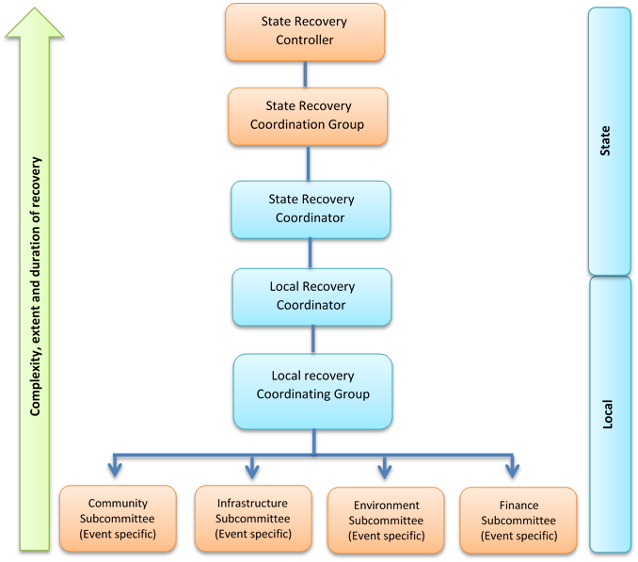

## 6.5 Commencement of Recovery

Local Recovery Coordinator:

The immediate involvement of the Local Recovery Coordinator (LRC) in any Incident Support Group (ISG) will ensure that recovery starts while response activities are still in progress, and key decisions taken during the response phase are able to be influenced with a view to recovery. The LRC may also attend the Incident Management Team (IMT) as an observer for further situational awareness.

The LRC shall:

* + Align response and recovery priorities
  + Connect with key agencies
  + Understand key impacts and tasks. Have input into the development of the Impact statement that will be used when the incident is transferred from response to recovery.
  + Identify recovery requirements and priorities as early as possible.
  + Establish a Local Recovery Committee, and any sub committees as required.

##### 

##### The Controlling Agency:

The Controlling Agency with responsibility for the response to an emergency will initiate recovery activity during the response to that emergency. To facilitate recovery, it will;

* + Liaise with the local recovery coordinator and include them in the incident management arrangements including the Incident Support Group or Operational Area Support Group.
  + Undertake an initial impact assessment for the emergency and provide that assessment to the local recovery coordinator and the State recovery coordinator
  + Coordinate completion of the Impact Statement, prior to cessation of the response, in accordance with the approved procedure (State EM Recovery Procedure 4) and in consultation with the ISG, the affected local government/s and the state recovery coordinator.
  + Provide risk management advice to the affected community.
  + Complete an Impact Statement document.

##### 

##### Local Recovery Coordination Group:

Where required, the LRC shall form a Local Recovery Coordination Group which shall consist of, as a guide, the following:

*Core Recovery Group:*

(Function – recovery planning, activation of plan, support Local recovery coordinator to manage the recovery process. The core group is usually made up of local government elected members and administration staff)

|  |  |  |
| --- | --- | --- |
| **Position** | **Primary** | **Alternate** |
| Chair | *President* | *Deputy President* |
| Local Recovery coordinator | *RSO - Yilgarn* | *Works Supervisor - Westonia* |
| Deputy Recovery coordinator | *CEO* | *CEO* |
| Administrative support | *As appointed* | *As appointed* |
| Communications officer | *As appointed* | *As appointed* |
| Any other LG officers as required ie financial /officer/Manager of Works | *As appointed* | *As appointed* |

*Co-opted members:*

(Function – these members would be co-opted as required to provide agency specific or expert advice and resources to assist the recovery process.)

|  |  |
| --- | --- |
| Hazard Management Agency or controlling Agency | DFES, Police |
| Essential services | Telstra, Water Corp, Main Roads, Western Power |
| Welfare agencies | Yilgarn Community Support Group Inc |
| Financial services | Centre link, Development commissions, Insurance providers, Chamber of Commerce |
| Dept of Health |  |
| Dept of Education |  |
| Dept of Transport |  |
| Dept of Food and Agriculture |  |
| Dept of Biodiversity Conservation and Attractions |  |
| WA Police |  |
| St John Ambulance |  |
| Community Groups or representatives. | CWA |
| CALD group representatives |  |
| Non-Government Organisations |  |

*Subcommittees:*

(Function – sub committees may be formed to assist the recovery process by considering specific priority areas)

Core priority areas that may require the formation of a subcommittee include;

* + - Economic / Finance Subcommittee
    - Infrastructure Subcommittee
    - Personal / Community Subcommittee
    - Environmental Subcommittee

Please refer to APPENDIX 6A: SUB COMMITTEES – OBJECTIVES for objectives and Terms of Reference for these four subcommittees should they need to be activated quickly.

##### 6.6 Priorities for Recovery:

Disasters can profoundly impact lives and livelihoods. Working with communities recovering from disasters is complex and challenging. These principles guide our efforts, approach, planning, and decision-making.

Planning for recovery is integral to emergency preparation, and mitigation actions may often be initiated as part of recovery.

Disaster recovery includes built, environmental and economic elements, all contributing to individual and social well-being.

The Shire of Westonia & Yilgarn aligns its priorities for recovery to the National Principles for Disaster Recovery.

While all the principles are equally critical to ensure adequate recovery, understanding the local and broader content and recognising complexity is foundational.

|  |  |  |
| --- | --- | --- |
|  | | |
| **Understand the CONTEXT** | Successful recovery is based on understanding the community context, with each community having its history, values and dynamics. |
| **Recognise COMPLEXITY** | Successful recovery responds to the complex and dynamic nature of emergencies and the community. |
| **Use COMMUNITY-**  **LED approaches** | Successful recovery is community-centred, responsive and flexible, engaging with the community and supporting them to move forward. |
| **COORDINATE all**  **activities** | Successful recovery requires a planned, coordinated and adaptive approach between community and partner agencies based on continuing assessment of impacts and needs. |
| **COMMUNICATE**  **effectively** | Successful recovery is built on effective communication between the affected community and other partners. |
| **Recognise and Build CAPACITY** | Successful recovery recognises supports and builds on individual, community and organisational capacity and resilience. |

The complete National Principles for Disaster recovery can be found at <https://knoweldge.aider.org.au/resources/national-prinicples-disster-recvoery>

## 6.6 Assessment and Operational Recovery Planning:

It is essential to assess the recovery and restoration requirements as soon as possible after the event's impact. This assessment will be based on the Impact Statement data provided by the Controlling Agency.

Depending upon the extent of the restoration and reconstruction required, the Local Recovery Coordinator and Local Recovery Coordinating Group should develop a specific Operational Recovery Management Plan to implement the recovery process. For an Operational Recovery Plan template, refer to Appendix 6 B: Operational Recovery Plan template

## 6.7 Resources

Recovery Resources:

The Local Recovery Coordinator for the Shire of Shire of Westonia & Yilgarn is responsible for determining the resources required for recovery activities in consultation with the Controlling Agency/Hazard Management Agency and Support Organisations.

The Shire of Westonia & Yilgarn resources are identified in the Contacts and Resources Register. The Local Recovery Coordinator (LRC) is responsible for coordinating the adequate provision of activities, resources and services for the Shire of Westonia & Yilgarn should an emergency occur.

The following table identifies suitable Local Recovery Coordination Centres in the Local Government area.

|  |  |  |  |
| --- | --- | --- | --- |
| **Centre Name** | **Address** | **Capacity and available resources** | **Contacts.** |
| Shire of Yilgarn Administration Centre | Antares Street, Sothern Cross | Network connections, backup power | EMRS 0407 491 027 |
| Shire of Yilgarn Works Depot Office | Arcturus Street, Southern Cross | Network Connection, backup power | EMI 0409 791 135 |
| Shire of Westonia – Administration Centre | Wolfram Street, Westonia |  | CEO 9046 7063 |
| Westonia Recreation Complex | Cement Street, Westonia |  | CEO 9046 7063 |

## 6.8 Financial Arrangements:

The primary responsibility for safeguarding and restoring public and private assets affected by an emergency rests with the asset owner, who needs to understand the level of risk and have appropriate mitigation strategies in place.

Through the Disaster Recovery Funding Arrangements – WA (DFRA-WA), the State Government provides a range of relief measures to assist communities in recovering from an eligible natural event. The Shire of Westonia & Yilgarn will make claims for recovery activities where they are deemed eligible under DFRA.

More information regarding DRFA is available from the State Emergency Management Committee web page - link - <https://www.dfes.wa.gov.au/recovery/Pages/default.aspx>.

DFES, as the State Administrator, may activate DRFA-WA for an eligible event if the estimated cost to the State of eligible measures is anticipated to exceed the Small Disaster Criterion (currently set at $240,000).

## 6.9 Financial Preparation:

The Shire of Westonia & Yilgarn will take the following actions to ensure they are prepared financially to undertake recovery activities should the need arise. These actions include:

* + Understanding and treating risks to the community through an appropriate risk management process;
  + Ensuring assets are recorded, maintained and adequately insured where possible;
  + Establishing a cash reserve for the purpose where it is considered appropriate for the level of risk;
  + Understanding the use of section 6.8(1) (b) or (c) of the Local Government Act 1995. Under this section, expenditure not included in the annual budget can be authorised in advance by an absolute majority decision of the Council or by the mayor or president in an emergency and then reported to the next ordinary meeting of the Council;
  + Understanding the use of section 6.11(2) of the Local Government Act 1995 to utilise a cash reserve established for another purpose, subject to one month’s public notice being given of the use for another purpose. Local Government Financial Management Regulations 1996 – regulation 18(a) provides an exemption for giving local public notice to change the use of money in a reserve where the mayor or president has authorised expenditure in an emergency. This would still require a formal decision of the Council before cash can be accessed.
  + Understanding the use of section 6.20(2) of the Local Government Act 1995 to borrow funds, subject to one month’s local public notice of the proposal and exercising of the power to borrow by an absolute majority decision of the Council;
  + Ensuring an understanding of the types of assistance that may be available under the Disaster Recovery Funding Arrangements- WA (DRFA-WA) and what local government may require to gain access to this potential assistance.
  + Understanding the need to manage cash flow requirements by using the option of submitting progressive claims for reimbursement from DRFA or Main Roads WA.

##### Managing Donations:

Organisations wishing to establish public appeals for cash donations should use the Lord Mayors Distress Relief Fund managed by the City of Perth, as detailed in the State EM Recovery Procedure1– Management of Public Fundraising and Donations. NOTE: Appeals for donations of physical items such as food and furniture should be discouraged unless specifically requested by the Local Recovery Coordination Group. In all instances, prospective donors should encourage cash donations and direct them to the Lord Mayor’s Distress Relief Fund.

## 6.10 Community Reactions

It is important to understand the common reactions that individuals and the affected community as a whole experience when they are touched by an emergency.

Understanding the psychosocial impacts of emergencies can provide insight into helping people get back on their feet and re-establish their post-emergency lives.

The below diagram illustrates the four-stage cycle of emotions that people are likely to experience after being impacted by an emergency. This process is indicative only. It should not be read as a sequential process but as a guide to help anticipate predictable challenges in the recovery stage.

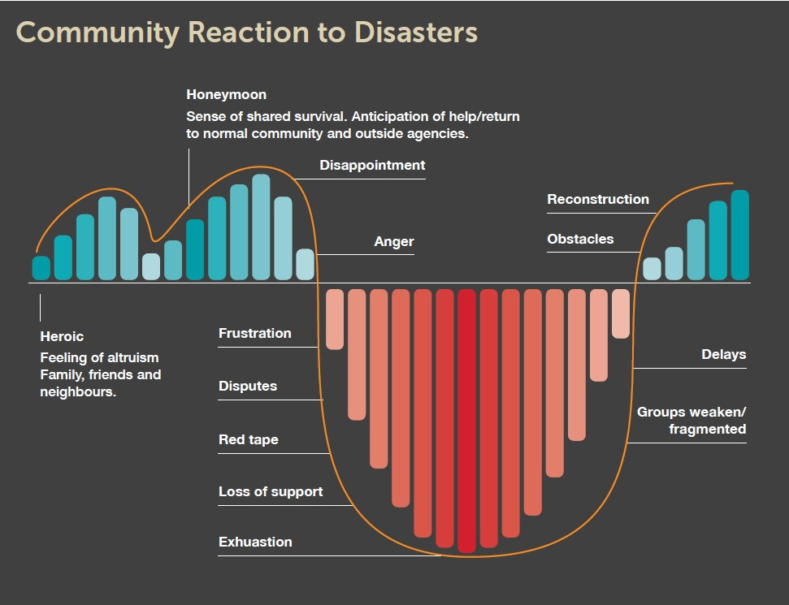

All recovery communications must be mindful of the cycle detailed above. Understanding this allows recovery communications to be carefully tailored for the community as they move through each phase.

## 6.11 Actions and Strategies

A list of recovery activities that may be undertaken together with suggested strategies has been provided to assist the Local Recovery Coordinator and the Local Recovery Coordinating Group. The list is not exhaustive but is meant as a prompt to initiate discussion and planning.

##### Activities:

* + - One Stop Shop
    - Short Term Accommodation
    - Counselling
    - Establish and manage emergency financial relief schemes
    - Surveying and assessing the damage to public and private property
    - Repairing and replacing public utilities, services and assets
    - Assisting with the repair or replacement of private property
    - Initiating programs to stimulate community morale and economic growth
    - Managing environmental rehabilitation programs
    - Coordinating recovery and research agencies
    - Revision of Land Use/ Planning schemes

##### Strategies:

*Community Involvement Strategies*

* + - Maximise the use of local resources, groups and individuals
    - Promote prior community awareness and education
    - Involve people in their own and their community recovery
    - Maintain continuous liaison between emergency teams, volunteer groups and community organisations
    - Create opportunities for local decision-making
    - Ensure self-determination in restoration planning
    - Maintain a cooperative relationship between volunteers and imported specialists
    - Use local suppliers
    - Empower the community as quickly as possible

*Recovery Information Strategies*

* + - Provide regular updates on –
    - current state & extent of the disaster,
    - actual and proposed official response
    - desired community response
    - advice to isolated families
    - Ensure everybody has an understanding of the situation and the opportunity for personal counselling
    - Provide for advocacy by agencies and organisations
    - Information may be made available to the public using a combination of the methods such as;
    - One Stop Shop
    - Door Knocks
    - Out Reach Programs
    - Information Sheets and or/ Community Newsletters

*Recovery Assistance Strategies*

* + - Provide for special needs of aged, ethnic, children, etc
    - Make food, shelter, clothing, health and emergency finance immediately available.
    - Deliver services in a simple & caring manner with minimal disruption to existing processes
    - Ensure the welfare centre caters for privacy and individual care
    - Ensure emergency workers receive ongoing support, debriefing, relief and rest
    - Maximise financial aid and minimise material aid

*Accountability Strategies*

* + - Ensure the affected community is involved in the allocation and distribution of material and financial resources
    - Assist the community in ensuring there is accountability in the use of resources

*Strategies for Grants, Loans and Gifts*

* + - Ensure there is community involvement in determining criteria
    - Communicate entitlement criteria for financial support & grants immediately
    - Alterations to criteria must be communicated clearly to the community
    - Consider non-English speaking groups in designing information for grants
    - Maintain confidentiality

*Strategies to Maintain Family Cohesion*

* + - Keep families together during evacuation and resettlement
    - Ensure all policies and processes support the family’s ability to recover

## APPENDIX 6A: Sub Committees– Objectives

|  |  |
| --- | --- |
| **Committee** | **Objectives** |
| Community (or Social) Subcommittee Objectives | * To provide advice and guidance to assist in the restoration and strengthening of community well-being at the event * To facilitate understanding of the needs of the impacted community about community wellbeing * To assess and recommend priority areas, projects, and events to assist with the recovery process in the immediate and short-term regarding the restoration and strengthening of community wellbeing * To assess and recommend medium and long-term priority areas to the local government for consideration to assist in the restoration and strengthening of community wellbeing * To ensure the affected community is informed and involved in recovery so that actions and programs match their needs. |
| Environment (or Natural) Subcommittee Objectives | * To provide advice and guidance to assist in the restoration of the natural environment after the event * To facilitate understanding of the needs of the impacted community about environmental restoration * To assess and recommend priority areas, projects and community education to assist with the recovery process in the immediate and short-term regarding the restoration of the environment, including weed management and impacts on wildlife * To assess and recommend medium- and long-term priority areas to the local government for consideration to assist in restoring the natural environment in the medium- to long-term. |
| Infrastructure (or Built) Subcommittee Objectives | * Assist in assessing requirements for the restoration of services and facilities in conjunction with the responsible agencies where appropriate * To provide advice and assist in the coordination of the restoration of infrastructure assets and essential services damaged or destroyed during the emergency * To assess and recommend priority infrastructure projects to assist with the short, medium and long-term recovery process. |
| Finance (or Economic) Subcommittee | To make recommendations to the Lord Mayor’s Distress Relief Fund (LMDRF) on the orderly and equitable disbursement of donations and offers of assistance to individuals who suffered personal loss and hardship due to the event.   * The development of eligibility criteria and procedures by which payments from the LMDRF will be made to affected individuals which:   + ensure the principles of equity, fairness, simplicity, and transparency apply   + ensure the procedures developed are straightforward and not demanding to individuals seeking assistance   + recognise the extent of loss suffered by individuals * complement other forms of relief and assistance provided by the government and the private sector; recognise immediate, short, medium and longer-term needs of affected individuals * ensure the privacy of individuals is protected at all times. * Facilitate the disbursement of financial donations from the corporate sector to affected individuals, where practical. |

## APPENDIX 6B: Aide Memoire Local Recovery Coordinator

**Local Recovery Coordinator Aide Memoire**

Local governments are to nominate a skilled Local Recovery Coordinator in their Local Emergency Management Arrangements. If the primary local recovery coordinator is unavailable during an event, more than one person should be appointed and trained.

ROLE

The Local Recovery Coordinator is responsible for developing and implementing recovery arrangements for the local government in conjunction with the Local Recovery Coordination Group (LRCG).

FUNCTIONS

Pre-Event

* Prepare, maintain and test the Local Recovery Plan in conjunction with the local government for endorsement by the Council of the local government;
* Ensure community engagement in recovery arrangements and increase community involvement in recovery preparedness, awareness and resilience;
* Identify vulnerable people within the community, such as youth, the aged, people with disabilities, Aboriginal people, and culturally and linguistically diverse people;
* Consider potential membership of the LRCG before an event occurs;

During Event

* Consult with the Controlling Agency regarding attending appropriate response meetings such as Incident Management Team, Incident Support Group and Operational Area Support Group meetings;
* Consider membership of the LRCG during an event-specific emergency based on the four recovery environments: social, built, economic and natural, or as required;
* Ensure the Controlling Agency with responsibility for the response to an emergency starts recovery activities during that emergency;
* Consult with the Controlling Agency on completing the [Impact Statement](https://semc.wa.gov.au/emergency-management/em-tools/Pages/Procedure-Attachments---Guides-and-Templates.aspx) before the transfer of responsibility for recovery to the affected local government(s);

Post-Event

* Provide advice to the Mayor/Shire President and Chief Executive Officer (CEO) on the need to convene the LRCG and provide guidance to the LRCG, if established;
* Ensure the local government provides LRCG with Executive Officer and administrative support, such as meeting agenda, minutes, and financial and administrative recordkeeping;
* Determine the required resources for effective recovery in consultation with the LRCG;
* Coordinate local-level recovery activities for the event according to the plans, strategies and policies determined by the LRCG;
* Monitor the progress of recovery and provide periodic reports to the LRCG and State Recovery Coordination Group, if established;
* Liaise with the State Recovery Coordinator on issues where State level support is required or where there are concerns with services from government agencies locally;
* Arrange for the conduct of an operational debriefing of all participating agencies and organisations as soon as possible after the arrangements have ended;
* Arrange an evaluation of the effectiveness of recovery activities within 12 months of the emergency to ensure lessons are captured and available for future managers and
* Provide recovery evaluations to the State Recovery Coordinator and the State Emergency Management Committee (SEMC).

MEMBERSHIP

The Local Recovery Coordinator should consider potential membership of the LRCG prior to an event occurring. During an emergency, consider membership that is event-specific. The following agencies and organisations may have a role in the LRCG.

**Core Members**

* Local Recovery Coordinator;
* critical local government staff and elected members;
* Community Recovery Coordinator and Community Liaison Officer;
* Controlling Agency;
* District Emergency Management Advisor; and
* local government networks, community members and community groups/associations /committees, e.g. environmental groups, farming groups, faith groups, sporting clubs, Aboriginal groups, schools, chambers of commerce and industry, etc.

**Potential Members – Event Specific**

* Australian Red Cross;
* Chamber of Commerce and Industry WA / Small Business Development Corporation;
* Department of Biodiversity, Conservation and Attractions;
* Department of Communities;
* Department of Education (or Local School Representative);
* Department of Fire and Emergency Services (DFES);
* Department of Health (or Local Health Services Provider/Officer);
* Department of Local Government, Sport and Cultural Industries;
* Department of Planning, Lands and Heritage;
* Department of Primary Industries and Regional Development;
* Essential Services Network Operators Reference Group representative;
* Essential Services such as:
  + - Alinta Gas;
    - Telstra Corporation;
    - Water Corporation; and
    - Western Power/Horizon Power.
* Insurance Council Australia;
* Main Roads Western Australia;
* Public Information Reference Group representative;
* Volunteering WA;
* Western Australia Police Force; and
* Western Australian Local Government Association.

**Support Services to LRCG**

The following agencies and organisations may provide support and advice to the LRCG on a range of topics such as the [Impact Statement](https://semc.wa.gov.au/emergency-management/em-tools/Pages/Procedure-Attachments---Guides-and-Templates.aspx); State Recovery Cadre; [Disaster Recovery Funding Arrangements Western Australia](https://www.dfes.wa.gov.au/recovery/Pages/DRFA-WA.aspx); environmental protection, clean up and waste management; Public Donations criteria for financial assistance; etc.:

* State Recovery (DFES);
* Department of Water and Environmental Regulation; and
* [Lord Mayor’s Distress Relief Fund](https://appealswa.org.au/) (City of Perth).**LOCAL RECOVERY COORDINATOR ACTION CHECKLIST**

(Please note this listing is a guide only and is not exhaustive)

**(Timeframes are approximate only)**

|  |  |
| --- | --- |
| **Task Description** |  |
| **Prior to Emergency** |  |
| Promote community awareness and engagement in recovery planning, including involvement in the development of a Local Recovery Plan. |  |
| Prepare, maintain and test the Local Recovery Plan in conjunction with local government for endorsement by the Council. |  |
| Ensure the completed Local Recovery Plan clarifies any recovery and operational agreements made between local governments (e.g., Memorandums of Understanding, loan staff, equipment sharing), roles and responsibilities, and records of all recovery expenditures. |  |
| Identify special needs people such as youth, the aged, people with disabilities, Aboriginal people, culturally and linguistically diverse people, and isolated and transient people. |  |
| Consider potential Local Recovery Coordination Group (LRCG) membership before an event occurs based on the social, built, economic and natural environments or as required. |  |
| **Within 48 hours** |  |
| Contact and alert vital local contacts. |  |
| Liaise with the Controlling Agency and participate (or nominate a suitable local government representative, e.g., the Local Recovery Coordinator, executive staff, or CEO) in the incident management arrangements, including the Incident Support Group and Operations Area Support Group, where appropriate. |  |
| Where more than one local government is affected, the local recovery coordinators should facilitate a coordinated approach, which the State Recovery Coordinator should support, as required. |  |
| Ensure an understanding of known or emerging impacts from the [Impact Statement](https://semc.wa.gov.au/emergency-management/em-tools/Pages/Procedure-Attachments---Guides-and-Templates.aspx) provided by the Controlling Agency. |  |
| Consult the Department of Primary Industries and Regional Development on special arrangements to manage the welfare of wildlife, livestock and companion animals. |  |
| Ensure the Controlling Agency starts recovery activities during the response to that emergency. |  |
| Provide advice to the Mayor/Shire President and CEO on the requirement to convene the LRCG and provide guidance to the LRCG if convened. |  |
| During an event, consider membership of the LRCG that is event-specific, based on the social, built, economic, and natural environments, or as required. |  |
| Consider the support required, such as resources to maintain records, including a record/log of events, actions, and decisions. |  |
| Ensure the local government provides LRCG with an Executive Officer and administrative support, such as meeting agendas, minutes, and financial and administrative recordkeeping (contact DFES State Recovery for advice or for possible State Recovery Cadre support). |  |
| Facilitate community meetings/briefings to provide relevant recovery information, including, as applicable, the Controlling Agency, State government agencies, and other recovery agencies. |  |
| Brief media on the recovery program throughout recovery, ensuring accurate and consistent messaging (use the local government’s media arrangements or seek advice or support from DFES State Recovery). |  |
| Develop and implement an event-specific Communication Plan, including public information, the appointment of a spokesperson, and the local government’s internal communication processes. |  |
| **Within one week** |  |
| Consider fatigue management for self and recovery staff throughout all recovery (contact DFES State Recovery for advice or possible State Recovery Cadre support). |  |
| Consult with the Controlling Agency to complete the Impact Statement before transferring responsibility for the recovery management to the local government. |  |
| Assess the community’s recovery requirements in conjunction with the controlling agency and other responsible agencies. Coordinate activities to rebuild, restore, and rehabilitate the community's social, built, economic, natural, and psychosocial well-being. |  |
| Liaise and meet with specific emergency management agencies involved with recovery operations to determine priority actions. |  |
| Assess for the LRCG the requirements for restoring services and facilities with the assistance of the responsible agencies, where appropriate. |  |
| Contact the [Disaster Recovery Funding Arrangements Western Australia](https://www.dfes.wa.gov.au/recovery/Pages/DRFA-WA.aspx) (DRFAWA) Officers to determine if the event is eligible under the DRFAWA. If so, ensure an understanding of what assistance measures are available and the process requirements for assistance. |  |
| If activated, understand the eligible criteria and payment procedures of the Lord Mayor’s Distress Relief Fund. Payments are coordinated through the local government to affected individuals. |  |
| Report on likely costs and establish a system for recording all expenditures during recovery (this includes logging expenditures, keeping receipts, and providing timesheets for paid labour). |  |
| Determine the acquisition and appropriate use of resources necessary for effective recovery. |  |
| Consider establishing a call centre with prepared responses for frequently asked questions. |  |
| Determine the level of State involvement in conjunction with the local government and the State Recovery Coordinator. |  |
| Liaise with the State Recovery Coordinator on issues where state-level support is required or where there are concerns about services from government agencies locally. |  |
| Ensure recovery activities are consistent with the [National Principles for Disaster Recovery](https://knowledge.aidr.org.au/resources/national-principles-disaster-recovery/). |  |
| **Within 1 to 12 months (or longer-term recovery)** |  |
| Monitor recovery progress and, if established, provide periodic reports throughout the recovery effort to the LRCG and State Recovery Coordination Group. |  |
| Ensure recovery projects that support the social, built, economic and natural recovery environments are community-led and targeted to best support affected communities. |  |
| Arrangements should be made for an operational debriefing of all participating agencies and organisations as soon as possible after the arrangements have ended. |  |
| Arrange for an evaluation of the effectiveness of recovery within 12 months of the emergency to ensure lessons are captured and available for future managers. |  |
| Provide recovery evaluations to the State Recovery Coordinator to refer to the SEMC for review. Evaluations can involve community and stakeholder surveys, interviews, workshops, and assessment of key project outcomes. |  |
| Social and personal support services are likely to be required in the longer term, and the need for a considerable period of psychosocial support (often several years) should be planned for. |  |

## APPENDIX 6D: Operational Recovery Plan Template

Shire of Westonia & Yilgarn

**Operational Recovery Plan**

**Emergency Type and location:**

**Date emergency occurred:**

**Section 1 – Introduction**

Incident description

Purpose of this plan

Authority

**Section 2 – Assessment of recovery requirements**

Details of loss and damage: (Refer to Comprehensive Impact Assessment)

Residential:

Commercial:

Industrial:

Transport:

Essential Services: *(include State and local government infrastructure)*

Estimates of damage costs:

Temporary accommodation requirements *(includes evacuation centres)*

Additional personnel requirements:

Human services: *(personal and psychological support requirements*

Other health issues:

**Section 3 – Organisational Aspects**

Details of the composition, structure and reporting lines of the groups/committees and subcommittees set up to manage the recovery process:

Details of inter-agency relationships and responsibilities:

Details of roles, key tasks and responsibilities of various groups/committees and those appointed to various positions including Recovery Coordinator:

**Section 4 – Operational Aspects**

Resources available:

Resources required:

Redevelopment plans: *(includes mitigation proposals)*

Reconstruction restoration program and priorities: *(Includes estimated timeframes, the programs and strategies of government agencies to restore essential services, plans for mitigation against future impacts. Include local government program for community services restoration.)*

Financial arrangements: *(Assistance programs (DFRA-WA), insurance, public appeals and donations)*

Public information dissemination *(Key messages, methods of distribution)*

**Section 5 – Administrative arrangements**

Administration of recovery funding: *(Include other financial issues)*

Public appeals policy and administration *(includes policies and strategies for office and living accommodation, furniture and equipment details for additional temporary personnel)*

**Section 6 – Conclusion**

*(Summarises goals, priorities and timetable of the plan).*

Endorsed by

**Chair, Local Recovery Coordinating Group**

**Dated:**

## 

## 6.13 Recovery Report

**STATE RECOVERY COORDINATING COMMITTEE RECOVERY REPORT – (Emergency Situation)**

Agency / Organisation:..........................................Report No: ............

To: Chairman, SRCC/State Recovery Coordinator

Situation Update should include full damage report (once only) and estimated amount in $, work in progress including estimated completion dates, details of difficulties or problems being experienced.

Proposed Activities: Should include plans and strategies for resumption of regular services (where appropriate), plans for mitigation works, dates of commencement and completion of reconstruction works, and possible disruption of activities of other agencies.

Special Assistance:

Requirements: Includes support from other agencies and SRCC intervention with priorities.

Financial Issues: This may include support from SRCC for additional funding from the Treasury.

Recommendations:

Signature

Title

This page has been intentionally left blank.

**Shire of Westonia & Yilgarn**

 

# SECTION SEVEN

# COMMUNICATIONS PLAN

## 7.0 Introduction

Communicating with an affected community is vital to all stages of emergency management. When threatened or impacted by an emergency, community members urgently need information and direction. The Hazard Management Agency is responsible for providing this information.

When communicating with an affected community, special consideration should be given to children and youth, older adults, people with disabilities, medically reliant persons, Aboriginal people, people who are isolated or transient, and people with Culturally and Linguistically Diverse backgrounds. For a list of groups/businesses to coordinate contact with vulnerable people, please refer to the VULNERABLE PEOPLE CONTACT GROUPS section in the Contacts and Resources section.

It is likely that individual agencies will want to issue media releases for their areas of responsibility (e.g., Water Corporate on water issues, Western Power on power issues, etc.). However, the release times, issues identified, and content shall be coordinated through the ISG to avoid conflict messages being given to the public.

All Council (Local Government) medical contact must be directed to the Shire President or Chief Executive Officer.

## 7.1 Communication Policy

Communication management in a crisis is critical. This section has been created to guide the Shire of Westonia & Yilgarn in approaching crisis communication in a structured, well-coordinated, and effective manner.

During a crisis, this response will be led by the Local Response Coordinator (LRC) with assistance from Key members of the Local Recovery Coordination Committee (LRCC). In managing media relations, the Local Recovery Coordination (LRCC) must seek direction from the Hazard Management Agency and the Shire of Westonia & Yilgarn CEO and Shire President.

## 7.2 Communication Principals

In an emergency, communication with stakeholders must adhere to the following principals

* + Timeliness - regularly updating stakeholders on the situation
  + Cooperation - being responsive and considerate to enquiries, deadlines and the other needs of stakeholders
  + Sensitivity - prioritising stakeholders, guarding sensitive information as needed
  + Transparency - remaining honest and open about the situation and progress
  + Simplicity - ensuring communication is easily understood and consistent
  + Accuracy - sharing only confirmed facts, never making assumptions or giving false information
  + Accountability - accepting responsibility if appropriate and reasonable.

## 7.3 Stakeholder Communication

If an emergency arises, a strategy specific to the situation will be developed to direct the communication response. The Local Recovery Coordination (LRCC) will prepare the communication strategy in collaboration with the President and CEO of the Shire of Westonia & Yilgarn.

The strategy will direct both internal and external communications, ensuring alignment with the Local Recovery Coordination (LRCC) response objectives and with the Shire of Westonia & Yilgarn's communications policy.

A well-managed and coordinated response will ensure the following occurs:

* + Communication is facilitated only by those authorised to do so
  + Information released is confirmed and accurate
  + Communication is regular and consistent and takes sensitivities into account.

## 7.4 Communicating in the Prevention Stage:

Prevention is “the mitigation or prevention of the probability of the occurrence of, and the potential adverse effect of, an emergency”.

The Shire of Westonia & Yilgarn employs several practices to aid in the prevention of emergencies, and these are communicated to the public. One example is the Firebreak Order distributed to the public every year, requiring firebreaks to be installed and properties to be clear of fire-hazardous materials by 15 September. This is an example *only*.

## 7.5 Communicating in the Preparedness Stage:

Preparedness is defined as “the preparation for response to an emergency”.

By increasing community preparedness, Emergency Management Agencies can educate stakeholders, networks and communities on potential emergency risks, impacts, and personal responsibility, promoting community resilience. By doing so, an EMA can;

* Raise awareness in high-risk areas about the importance of planning and preparing (i.e. for cyclones, floods and bushfires);
* Raise personal awareness of risks and the need for adequate insurance;
* Increase adoption of preparedness measures and appropriate response behaviours in high-risk areas;
* Increase understanding of how to prevent, prepare for, respond to and recover from the hazards particular communities will face.

###### 7.6 Public Warning Systems

During an emergency, one of the most critical components of managing an incident is getting information out to the public promptly and efficiently. Such information should include the following information:

* Where to go
* The safest route to take
* What to take ( Medications etc)

This section highlights local communication strategies.

*Local Systems*

* + Notice Boards
    - Shire of Westonia & Yilgarn Notice Board
    - Community Newsletter
    - Variable Message Boards.
    - Information would also be publicly displayed at any evacuation centres that were opened due to the emergency.
  + Shire of Westonia & Yilgarn Facebook
  + Shire Website [www.westonia.wa.gov.au](http://www.westonia.wa.gov.au) [www.yilgarn.wa.gov.au](http://www.yilgarn.wa.gov.au)
  + Telstra SMS and Email Service

*State Systems*

During a significant emergency, you can also find information on the following;

* + DFES’s recorded information line
  + Emergency broadcast on your local Radio Station Frequency
  + TV and radio news bulletins, print and online newspapers
  + A staffed communication information line may be set up
  + A TV crawler displaying messages at the bottom of the screen may be used.
  + Standard Emergency Warning Signal (SEWS):

SEWS is a distinctive siren sound that alerts the community to the broadcast of an urgent safety message related to a major emergency or disaster. It is intended to be used as an alert signal on public media such as radio, television, public address systems, and mobile sirens.

In Western Australia, the broadcast of SEWS for flood and weather events is authorised by the Department of Fire and Emergency Services or the Regional Director of the Bureau of Meteorology.

*DFES Public Info line*

Website [www.dfes.wa.gov.au](http://www.dfes.wa.gov.au/) and [www.emergency.wa.gov.au](http://www.emergency.wa.gov.au)

Telephone 13 3337 (13DFES) (For emergency information only) – OR 1300 657 209 (recorded information line).

**ABC Radio**

ABC Mid West and Wheatbelt

1300 501 222

Geraldton

08 9923 4111

**Midwest Radio**

08 9362 6664

**State Alert System**

1300 253 787

**Emergency WA Website**

[https://www.emergency.wa.gov.au/#](https://www.emergency.wa.gov.au/)

*State Alert*

StateAlert is a web-based system designed for Emergency Services to deliver community warnings regarding emergencies through:

* + Recorded voice – Landline and mobile, and
  + Text – mobile telephone, email and RRS feed.

StateAlert is also available for external HMAs to use in situations where lives may be in danger. All requests for StateAlert messaging will be evaluated to ensure the need is commensurate with both the definition of Emergency and that the proposed release of StateAlert is classed as a ‘life-threatening’ incident.

## 7.6 Communicating in the Response Stage:

Communities affected by an emergency have a vital and urgent need for information. Emergency public information aims to provide the public with consistent, adequate and timely information and instructions.

The Controlling Agency or Hazard Management Agency will decide to evacuate a community or part of it should it be threatened by an emergency. They will also decide how best to communicate the evacuation suggestion or order to community members.

## 7.7 Communicating in the Recovery Stage:

Recovery communications refers to sending, gathering, managing and evaluating information in the recovery stage following an emergency.

When communicating with the public in the Recovery stage, it is essential to understand the common reactions that individuals and the community are likely to experience due to the emergency.

Ensure all messaging adheres to the Giuliani method of communication information, which includes:

* What we know;
* What we don’t know;
* What we are doing; and
* What we want you to do

##### Status Update

The status update is the first information assessment about what is happening, providing crucial information about the emergency and recovery efforts. It is maintained in summary form daily and informs key talking points for the Shire of Westonia & Yilgarn.

##### Talking Points

The talking points are developed from information contained within the status updates.

The talking points provide key messages to be used by the spokesperson and all members of the Shire who are in contact with the affected community and the general public. Talking points can be used for all communication methods, such as the newsletter, community meetings, etc.

##### Social Media Applications

Social media can effectively engage the community during emergencies and recovery. The Shire is committed to regular use, monitoring, *and reliable updating*.

##### Media Release

Media releases can provide vital instant information that can be picked up by the local newspaper or radio station. The designated local government spokesperson must be used in the media release. Consider co-branded media releases that relate to a specific stakeholder in the early stages of the response to the recovery phase.

##### Community Meetings

Community meetings are essential in response and recovery. It is vital to address the community in a face-to-face setting early to earn the trust and respect of the affected community and engage in meaningful dialogue. Community meetings may involve many state government agencies, such as the Hazard Management Agency, local government, and community organisation representatives. The local government must delegate the Master of Ceremony and spokesperson.

##### Notice Boards

A central notice board at a key location in the community can provide information on recovery. This location may already be being used or one that is decided to be best suited for the emergency and recovery effort.

* + The information must be general and local and provide people with call-to-actions, such as contact numbers and places to go for additional information.
  + The notice board may also be used to gain feedback directly from the community if required.

Media Conference

A media conference can be used if there is public and media interest after the emergency and to get specific messages across to the media, the general public, and the community.

* + A media conference should be managed by the Media Liaison function located within the Recovery Communications team.
  + The announcement will need to be prepared, the spokesperson chosen and briefed, and the time of the conference chosen to suit the relevant media deadline

##### Community Newsletter

A community newsletter that is printed or emailed is a simple and easy method of communication in recovery.

##### Newspaper Article

The newspaper may pick up an article from the media release that has been issued; the local government may be given a regular space each week to address the issues in recovery for the community or be able to place paid advertising within the newspaper.

Recovery Communications Plan

A recovery communications plan details the local governments’ strategy for communicating with and consulting with the affected community during recovery.

A copy of a basic communications plan template can be found in *Appendix 7A*

###### Managing the Media

During a crisis, the information used in the communication response must be controlled. The approvals/sign-off procedure must be followed to ensure that all facts are accurate and their release is authorised. The Local Response Coordinator (LRC) is responsible for enforcing this procedure, which is as follows:

* + Facts will be verified internally through update briefings within the Local Recovery Coordination Committee (LRCC). Information is never to be assumed
  + The Local Recovery Coordination Committee (LRCC) will draft documents for release to external stakeholders
  + The Local Response Coordinator (LRC) must confirm all incident-related facts
  + The chair of the Local Recovery Coordination Committee (LRCC) will coordinate the CEO's final sign-off before the document is released.

Having one authorised spokesperson during a crisis ensures that communication with the media and audiences is consistent, transparent and controlled. Designated spokespeople may include:

* + Shire of Westonia & Yilgarn – CEO
  + Shire President
  + Incident relevant elected representative

They must have the updated facts and be available and prepared to manage media relations. All employees must know the procedure for handling enquiries and learn to direct calls and visitors appropriately.

General Enquiries

Frontline employees outside the Local Recovery Coordination Committee (LRCC) must be prepared to receive enquiries from various stakeholders. The Shire of Westonia & Yilgarn's Communication advisor will ensure that they are provided with a script based on the key messages and a copy of the prepared Q&As and must brief them on the communication policies. Other than approved spokespeople, no employee is authorised to comment on any stakeholder beyond the script's scope and these documents.

* + No employee or spokesperson is to give “off the record” or “in confidence” information
  + All media releases and holding statements must go through the approvals process before release, with final sign-off from the CEO or Local Recovery Coordination Committee (LRCC) Chair.

## 

## APPENDIX 7A Recovery Communications Plan Template

**SHIRE OF Westonia & Yilgarn**

**RECOVERY COMMUNICATION PLAN**

Recovery Vision for the affected Community.

**Vision**

###### Mission

The mission of the recovery communications plan.

|  |  |
| --- | --- |
| **Why?** |  |
| **Who?** |  |
| **What?** |  |
| **When?** |  |
| **Where?** |  |
| **How?** |  |

**BACKGROUND**

A brief detailed description of the emergency events.

**COMMUNICATION OBJECTIVES**

Clear, measurable and achievable objectives. No more than five.

###### Key Target Audience

Who are the key community members targeted, and how is this done? Who is responsible for the communication method, and by whom?

|  |  |
| --- | --- |
| **Target Audience** |  |
| **Descriptions** |  |
| **Actions** |  |
| **Who** |  |
| **By When** |  |

Key Messages

What are the current key messages, how are they distributed, and to whom?

|  |  |
| --- | --- |
| **Message** |  |
| **Method** |  |
| **Who** |  |

Actions

What communications are being undertaken to which stakeholder group, and how is this done?

Who has responsibility, and how often will they be distributed and updated?

|  |  |
| --- | --- |
| **Stakeholder Group** |  |
| **Communication** |  |
| **Method** |  |
| **Who** |  |
| **Frequency** |  |

###### Monitor and Evaluate

How is each communication method being monitored and evaluated for effectiveness? How often will they be monitored and assessed?

|  |  |
| --- | --- |
| **Method** |  |
| **Monitor and Evaluate** |  |
| **Frequency** |  |

###### Communications Budget

How much money has been allocated for each communication method? It is essential to keep up-to-date records of how much is being spent against the budget.

|  |  |
| --- | --- |
| **Method** |  |
| **Amount Allocated** |  |
| **Amount Spend/Date** |  |

###### Communications Plan Review

Who is responsible for monitoring the complete recovery communications plan, what date was it reviewed, and what were the significant changes made?

|  |  |
| --- | --- |
| **By Whom** |  |
| **Date** |  |
| **Major Changes** |  |

**(This page has been intentionally left blank)**

**Shire of Westonia & Yilgarn**

 

# SECTION EIGHT

# CONTACTS AND RESOURCES REGISTER

###### Please note that this section of the LEMA is private and confidential. The information in this section is available only to emergency management personnel and is not available for public viewing.