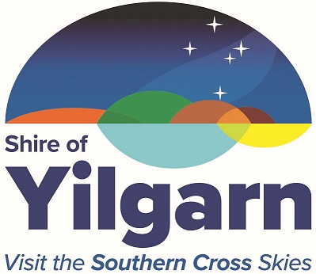

FOOD BUSINESS NOTIFICATION AND REGISTRATION FORM

Please tick if updating details only. (Change of ownership requires new notification)
Please tick if registered with another Local Government being _____________________________
Contact details
Name of Proprietor/s (in full):

Proprietor Address (not food business location):

Proprietor Postal Address:

Phone: | Mobile: | Fax:
Email:

Food Premises Details

Name of Food Business (in full):

Address of Food Business:

Is your premise within a residential property Yes No
ABN/ACN:

Are you a charitable or non-for-profit organisation Yes No

Hours of operation: (Main Business Location)
Monday |  | Friday
Tuesday |  | Saturday
Wednesday |  | Sunday
Thursday

Food Business Information
Do you provide, produce or manufacture any of the following foods?
Please tick all boxes that apply (there may be more than one)
- Prepared, ready to eat table meals  - Frozen meals  - Raw meat, poultry or seafood (i.e. oysters)  - Processed meat, poultry or seafood  - Fermented meat products  - Meat pies, sausage rolls or hot dogs  - Sandwiches or rolls  - Soft drinks/juices  - Raw fruit and vegetables | - Processed fruit and vegetables Prepared salads  - Confectionary  - Infant or baby foods  - Bread, pastries or cakes  - Egg or egg products  - Dairy products  - Other: _________________________  ______________________________

Business Type
Please tick all that apply
- Bakery  - Butcher  - Canteen/kitchen  - Caterer  - Charitable or community organisation  - Childcare. No of children ____  - Delicatessen  - Distributor/importer | - Fast Food Takeaway/Snack Bar  - Food Service  - Frozen Food  - Fruit and Vegetable  - Home delivery  - Hospital/nursing home  - Manufacturer/processor  - Market stall  - Meals-on-wheels | - Mobile food operator  - Packer  - Restaurant/Café  - Retailer  - Storage  - Supermarket  - Temporary food premises  - Transport  - Other: ________________

Please provide a brief description of your food business operations/activities
(For example: Bakery – preparing and baking bread, pastries, cakes, pies and sausage rolls. Pies and sausage rolls heated for direct sale)

Additional Information Required for new premises
All Food Businesses:
- Design, layout and Fit-out specifications of the premise
- Sample Menu.
Manufacturing Food Businesses:
- Copies of food labels where products are to be sold as packaged goods.
Food Premises registered with alternate Local Council
- Copy of Food Act 2008 Registration Certificate from local authority.
Fees
A $60.00 registration fee applies to food businesses registering for the first time with the Shire, with the exception on the following business types:
- Charitable or not-for profit;
- Exempt food businesses (check with Executive Manager Regulatory Services);
- Food businesses already registered with another Local Government.
Declaration:
I, the person/s making this application declare that the information contained in this application is true and correct in every particular.

Signature of applicant/s:

Date:

* Payment can be made:
- In person at the Shire Offices, 23 Antares St, Southern Cross
- Cheque or money order attached to this application
- Providing credit card details below.
Credit Card Payments (Incurs 1.5% fee)
Mastercard Visa
Name on Card: | Expiry: | CVC:
Card Number  __ __ __ __ __ __ __ __ __ __ __ __ __ __ __ __ | Amount: $ 60.90*  *Includes CC fee
Signature: | Date:

