

**Freedom of Information Act 1992**

**Information Statement**

Contents

1. STRUCTURE OF ORGANISATION 3

1.1 COUNCIL 3

1.2 ADMINISTRATION 3

2. PUBLIC EFFECT OF THE ORGANISATION’S FUNCTIONS 4

2.1 DECISION MAKING 4

2.2 LEGISLATION, REGULATIONS, BY-LAWS AND POWERS 5

2.2.1 ACTS 5

2.2.2 COUNCIL LOCAL LAWS 7

2.2.3 TOWN PLANNING SCHEME 7

3. POLICY FORMULATION - PUBLIC PARTICIPATION 8

3.1 POLICIES 8

3.2 DELEGATION OF AUTHORITY 8

3.3 ANNUAL GENERAL MEETING OF ELECTORS 8

3.4 SUB-COMMITTEES AND CONSULTATIVE GROUPS 8

3.5 SERVICES 9

4. DOCUMENTS HELD BY THE ORGANISATION 9

4.1 DOCUMENTS AVAILABLE FOR INSPECTION BY THE PUBLIC 9

4.2 DOCUMENTS COVERED BY THE ACT 9

5. ACCESS PROCEDURES AND ARRANGEMENTS 10

5.1 APPLICATIONS AND FORMS OF ACCESS 10

5.1.1 APPLICATIONS 10

5.1.2 FEES AND CHARGES 11

5.1.3 FORMS OF ACCESS 11

5.1.4 NOTICE OF DECISION 11

5.2 THE REVIEW PROCESS 11

5.2.1 INTERNAL REVIEW 12

5.2.2 EXTERNAL REVIEW 12

5.3 AMENDMENTS PROCEDURE 12

# STRUCTURE OF ORGANISATION

## COUNCIL

**SHIRE PRESIDENT**: Cr Wayne Della Bosca

**DEPUTY SHIRE PRESIDENT**: Cr Bryan Close

Cr Wayne Della Bosca Mobile: 0427 957 206

Email: [cr_wdellabosca@yilgarn.wa.gov.au](mailto:cr_wdellabosca@yilgarn.wa.gov.au)

Cr Bryan Close Mobile: 0409 825 317

Email: [cr_close@yilgarn.wa.gov.au](mailto:cr_close@yilgarn.wa.gov.au)

Cr Gary Guerini Phone: 9049 1328

Mobile: 0429 010 147

Email: [cr_guerini@yilgarn.wa.gov.au](mailto:cr_guerini@yilgarn.wa.gov.au)

Cr Lisa Granich Mobile: 0418 491 400

Email: [cr_granich@yilgarn.wa.gov.au](mailto:cr_granich@yilgarn.wa.gov.au)

Cr Linda Rose Mobile: 0437 530 848

Email: [cr_rose@yilgarn.wa.gov.au](mailto:cr_rose@yilgarn.wa.gov.au)

Cr Bianca Bradford Mobile: 0429 001 817

Email: [cr_bradford@yilgarn.wa.gov.au](mailto:cr_bradford@yilgarn.wa.gov.au)

Cr Donna Newbury Mobile: 0497 769 676

Email: [cr_newbury@yilgarn.wa.gov.au](mailto:cr_newbury@yilgarn.wa.gov.au)

## ADMINISTRATION

The Chief Executive Officer is responsible for (amongst other things) the administration of Council policy, and the efficient management of the day to day operations of the local government.

An organisational structure of the Shire of Yilgarn follows:

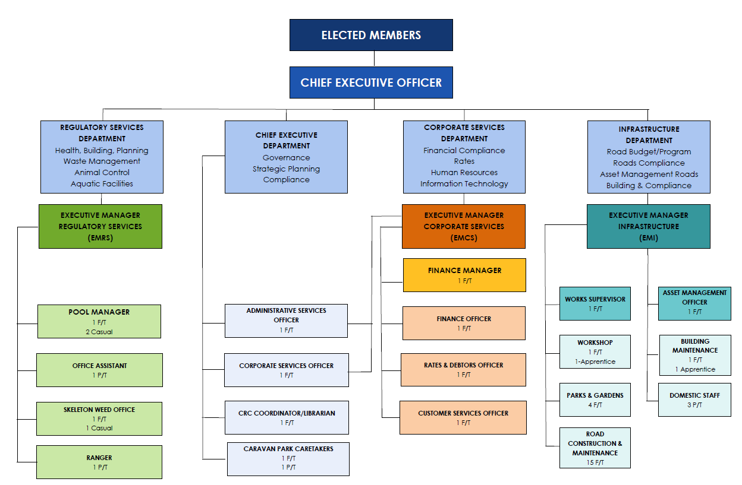

# PUBLIC EFFECT OF THE ORGANISATION’S FUNCTIONS

## DECISION MAKING

The Shire of Yilgarn provides a wide range of services and facilities for its residents, ratepayers and visitors to the Shire. The Shire also has a role in the management, improvement and development of the resources within its area so as to create a safe and pleasant environment for its residents and ratepayers.

General information relating to the Shire can be found on the Shires website. The Shire of Yilgarn produces the Shire Budget News annually and is distributed with the Rates Notices, copies are also available from the Shire Offices. These sources of information are designed to keep the public informed of the various issues being undertaken by the Shire of Yilgarn.

Council

Council, consisting of seven Councillors, is the decision making body on all policy matters. Council meets monthly with Ordinary Meetings of Council being held on the third Thursday of every month commencing at 4.00 pm.

Members of the public are welcome to attend all meetings of Council. A public question time of at least 15 minutes duration is scheduled at the commencement of all public meetings.

Agendas and Minutes

Agendas for Ordinary Council Meetings are available to members of the public four days prior to meetings. Minutes are placed on the Shire of Yilgarn website within ten working days after each meeting.

## LEGISLATION, REGULATIONS, BY-LAWS AND POWERS

### 2.2.1 ACTS

A number of Acts of Parliament give the Shire of Yilgarn the necessary powers to make decisions regarding the natural, built and legal environments which it administers. Listed below are the principle Acts which are briefly described:

Local Government Act 1995 and Associated Regulations

This Act enables the Shire of Yilgarn to administer its local government area. Local authorities operate strictly within the Act and are not able to undertake actions, activities or services that are not specifically provided for in this or other legislation.

Bush Fires Act 1954 and Associated Regulations

This Act makes provisions for the prevention, control and extinguishment of bush fires.

Caravan Parks and Camping Grounds Act 1995 and Associated Regulations

This Act makes provisions for the operation of caravan parks and camping grounds.

Cat Act 2011 and Associated Regulations

This Act controls the registration, ownership and keeping of cats and the obligations and rights of persons in relation thereto.

Cemeteries Act 1986

This Act provides for the declaration and management of cemeteries, the establishment, constitution and functions of cemetery boards, the licensing of funeral directors, the regulation of burials and related purposes.

Disability Services Act 1993

This Act provides services for people with disabilities.

Dog Act 1976 and Associated Regulations

This Act controls the registration, ownership and keeping of dogs and the obligations and rights of persons in relation thereto.

Environment Protection Act 1986

This Act provides for an Environmental Protection Authority, the prevention, control and abatement of environmental pollution and for the conservation, preservation, protection, enhancement and management of the environment.

Freedom of Information Act 1992

This Act to provides for public access to documents and to enable the public to ensure that personal information in documents is accurate, complete, up-to-date and not misleading.

Public Health Act 2016, Health (Miscellaneous Provisions) Act 1911 and Associated Regulations

This Act regulates matters relating to sewerage and drainage, water pollution, medical services, public and private buildings, nuisances, offensive trades, medical services, the control of disease and medicines and pharmaceuticals.

Heritage Act 2018

This Act requires all local authorities to compile and regularly review an inventory of local places which are significant or may become significant heritage properties.

Liquor Licensing Act 1988 and Associated Regulations

This Act, administered in part by local government, regulates the sale, supply and consumption of liquor, the use of premises on which liquor is sold and the services and facilities provided in conjunction with or ancillary to the sale of liquor.

Litter Act 1979 and Associated Regulations

This Act to makes provision for the abatement of litter and establishes, incorporates and confers powers upon the Keep Australia Beautiful Council (WA).

Work Health and Safety Act 2020 and Association Regulations

This Act, administered in part by local government, promotes and improves standards for occupational health, safety and welfare and regulates the administration of the laws relating to occupational health, safety and welfare and incidental purposes.

Public Works Act 1902

This Act governs the laws relating to authorising public works, surveys, investigations for water, roads, rivers and bridges, railways and related matters.

Rates and Charges (Rebates and Deferments) Act 1992

This Act permits administrative authorities to allow rebates on, or the deferral of payment of certain amounts payable by way of rates or charges by pensioners and other eligible persons.

Strata Titles Act 1985

This Act facilitates the subdivision of land and the disposition of titles thereto and incidental purposes.

Planning and Development Act 2005

This Act provides for the planning and development of land for urban, suburban and rural purposes. The general objective of this Act is to promote and develop land to the best possible advantage and to balance the use of all land resources.

Building Act 2011

This Act regulates the construction and modification of buildings.

Valuation of Land Act 1978

An Act to provide for the valuation of land and other purposes.

### 2.2.2 COUNCIL LOCAL LAWS

Local laws may be adopted by Council to regulate and govern local issues. Council has adopted local laws relating to:

* Trading in Public Places
* Health
* Dogs
* Standing Orders for Council Meetings
* Fencing

### 2.2.3 TOWN PLANNING SCHEME

The Shire of Yilgarn operates under Town Planning Scheme No 2, which was gazetted in 1998.

The purpose of the Scheme is to:

1. Control land development
2. Secure the protection of the environment of the Scheme Area
3. Other matters authorised by the Planning and Development Act 2005

# POLICY FORMULATION - PUBLIC PARTICIPATION

## POLICIES

Council adopts Polices on a variety of issues to act as a guide for Officers of the Shire of Yilgarn and provide the basis for decision making. All current Policies are contained within the Council’s Policy Manual along with a register of authorised delegations made by the Council to assist with the efficient administration of the municipality.

## DELEGATION OF AUTHORITY

The Chief Executive Officer has delegated authority from Council to make decisions on a number of specified administrative and policy matters.

## ANNUAL GENERAL MEETING OF ELECTORS

The Annual General Meeting of Electors is held once in every financial year and includes the presentation of the Annual Report and the Auditor’s Report. Residents and Ratepayers are encouraged to attend this meeting as it is an opportunity to ask questions and raise issues with local representatives.

## SUB-COMMITTEES AND CONSULTATIVE GROUPS

Council Committees comprise:

Audit Committee

Local Emergency Management Committee Bushfire Advisory Committee

Shire of Yilgarn History Advisory Committee

The Council has appointed Elected Members to the following Working Groups:

Health Agencies of the Yilgarn

Yilgarn Local Action Group

Wheatbelt East Regional Organisation of Councils

Great Eastern Country Zone

Mt Walton Intractable Waste Disposal Facility Community Liaison Committee Great Western Woodlands Reference Group

Wheatbelt North Regional Road Group and Sub Group

Eastern Wheatbelt Declared Species Group

Rural Health West

District Health Advisory Committee Wheatbelt Ag Care

Central Easter Aged Care Alliance Inc Wheatbelt Communities Inc

Shire of Yilgarn Roads Committee

## SERVICES

Council provides a range of services to the community in many areas including:

Roads/Footpaths/Kerbing Street Lighting

Litter Bins Public Toilets

Public Libraries Playground Equipment

Dog Control Environmental Health Matters Recreational/Sporting Facilities Stormwater Drainage

Street Tree Planting Rubbish Collection

Streetscape Youth and Community Services

Parks and Reserves Community Halls and Centres

Planning and Building Control Emergency Response Services Citizenships Bush Fire Control

Tourism and Economic Promotion Cemeteries

# DOCUMENTS HELD BY THE ORGANISATION

## DOCUMENTS AVAILABLE FOR INSPECTION BY THE PUBLIC

The Shire of Yilgarn has a variety of documents available for public inspection or purchase. Annual Reports, Local Laws, Budgets, Ratebook and Policies are available for inspection during normal office hours or can be viewed on the Shire of Yilgarn website.

A copy of Council agendas and minutes can be viewed at the Shire offices or on the Shire of Yilgarn website

The Shire of Yilgarn administration office has available a selection of community information brochures.

## DOCUMENTS COVERED BY THE ACT

Documents and information covered by the Freedom of Information Act include various items such as maps, plans, personnel records, client records, building files and correspondence.

All documents received are filed, with files being divided into categories as follows:

* Administration
* Property Assessments
* Associations and Committees
* Building
* Government Departments and Organisations
* Finance
* Fire and Emergency Services
* Health
* Personnel
* Rating
* Recreation
* Reserves
* Roads
* Tenders
* Town Planning
* Tourism
* Welfare and Community Services
* Works and Services

# ACCESS PROCEDURES AND ARRANGEMENTS

It is the aim of the Council to make information available promptly and at the least possible cost; whenever possible documents will be provided outside the Freedom of Information process.

If information is not routinely available, the Freedom of Information Act 1992 provides the right to apply for access to documents held by the council and to enable the public to ensure that personal information in documents is accurate, complete, up to date and not misleading.

## APPLICATIONS AND FORMS OF ACCESS

### 5.1.1 APPLICATIONS

For applications to be accurately and promptly dealt with, requests must ensure sufficient information is supplied to enable the correct document(s) to be identified.

The Shire of Yilgarn may request proof of identity.

If a person is seeking access to a document or documents on behalf of another person the Shire of Yilgarn may require authorisation, usually in writing.

Applications will be dealt with as soon as practicable (within 45 days) after it being received.

Applications should be addressed to:

FOI Co-ordinator

Shire of Yilgarn

PO Box 86 SOUTHERN CROSS WA 6426

or by delivery to the Shire Offices at 23 Antares Street, Southern Cross between the hours of 8.30am and 4.30pm Monday to Friday.

It should be noted that some documents are for viewing only and cannot be copied, as this would be in breach of the Copyright Act.

### 5.1.2 FEES AND CHARGES

The following fees and charges were adopted by Council and are to be seen as maximum charges:

* + - * No fee for access applications relating to personal information and amendment of personal information
      * Application fee of $30 for other access applications (non-personal information)
      * A fee of $30 per hour for staff time for dealing with an application
      * A fee of $30 per hour of staff time for supervision by staff when access is given to view the documents.
      * Photocopying charges as per the fees in the Southern Cross Community Resource Centre section of the Fees and Charges
      * Delivery, packaging and postage will be charged at actual cost

### 5.1.3 FORMS OF ACCESS

Requests for access to documents can be made by way of inspection, a copy of a document, a USB, a transcript of a recorded document or of words recorded in shorthand or encoded form, or a written document in the case of a document where words can be reproduced in written form. Where the Shire is unable to grant access in the form requested, access may be given in a different form.

### 5.1.4 NOTICE OF DECISION

As soon as possible, but in any case, within 45 days you will be provided with a notice of decision which will include details such as:

* + - * the date on which the decision was made
      * the name and the designation of the officer who made the decision
      * if the document is an exempt document the reasons for classifying the matter as exempt or the fact that access is given to an edited document
      * information on the right to review and the procedures to be followed to exercise those rights.

## THE REVIEW PROCESS

The Freedom of Information Act provides for a review and appeal process. Applicants may seek an Internal Review if they are dissatisfied with the decision of the Freedom of Information Coordinator. If they are still dissatisfied following the internal review then a review by the Information Commissioner may be requested. If still not satisfied, applicants may appeal to the Supreme Court.

### 5.2.1 INTERNAL REVIEW

Applicants who are not satisfied with the decision of the FOI Co-ordinator can apply to the Shire of Yilgarn for an Internal Review of that decision. Applications for an Internal Review must be lodged at the Shire within 30 days of receipt of notice of the Shire’s decision. The Shire will respond within 15 days or any longer period agreed between the applicant and the Shire. The Internal Review will be carried out by the Chief Executive Officer. There is no charge for an internal review.

### 5.2.2 EXTERNAL REVIEW

Applicants who are still dissatisfied after the Internal Review has been completed may seek a review by the Information Commissioner. This request must be made in writing, giving details of the decision to which the complaint relates. Complaints should be made to the Information Commissioner and addressed as follows:

The Office of the Information Commissioner Albert Facey House

469 Wellington Street

PERTH WA 6000

Any party to a complaint may appeal to the Supreme Court on any question of law arising out of a decision of the Information Commissioner, except for a decision as to the deferral of access to a document, the charges to be imposed for dealing with an access application and the payment of a deposit on account of charges.

## AMENDMENTS PROCEDURE

An individual may apply to have a document amended if it contains inaccurate, incomplete, out of date or misleading personal information. An application should be made in writing to the Shire of Yilgarn and should provide all the information required in the Act (Amendment forms are available from the Shire Offices) Applicants must provide details and, if necessary, documentation in support of their claim that the information they seek to have amended is inaccurate, incomplete, out of date or misleading. Applications must also indicate how they wish the amendment to be made (e.g. alteration, insertion, etc).

|  |  |
| --- | --- |
| **Effective From:** | 19 December 2019 |
| **Expires on:** | Does not expire |
| **Reviewed:** | July 2022  July 2024 – Councillors Amended |
| **Adopted by Council:** | 19 December 2019 |

